Computing, Digital Forensics and Cybersecurity  
BSc (Hons.) Computer Science  
2022-23  
Individual Project 40 MCOMD3PRJ  
Title: Match Predictor and Analytical Tool for League of Legends  
Author: Nathan Smallcalder  
Supervisor: Vijay Sahota  
E-mail: [ns60@canterbury.ac.uk](mailto:ns60@canterbury.ac.uk)

This report is submitted in partial fulfilment of the requirement for the BSc in Computer Science at Canterbury Christ Church University.

I declare that this report is my own original work containing no personal data as defined in the Data Protection Act and that I have read, understood, and accept the University’s regulations on plagiarism/intellectual property rights/research ethics (in particular the Research Governance Handbook) and the Individual Project 20 Module Handbook in its entirety.

Further, I accept that digital and/or hard copies of my Individual Project 40, or parts thereof, may be made available to other students, individuals, and organisations after it has been marked.

Finally, I accept that no copy of my Individual Project 20 will ever be returned regardless of the circumstances.

Signed Nathan Smallcalder  
Date of Submission: 3rd May 2023

### Abstract

Electronic Sports (eSports) are competitive videogames played in leagues or tournament settings which can offer large prizes for winning. eSports has recently gained popularity, with large viewership worldwide League of Legends is one of the most popular eSports. Providing a tool that can analyse players’ statistics and predict matches at both professional and casual levels could provide a clear path to improvement for players to take the next step in their game. In this project, the waterfall model is adopted to create an application that analyses users’ statistics using the Riot API, which then stores the data in a database to be used in a machine-learning model to predict live matches or scenarios made by the user. Several machine learning models are reviewed and compared to select two machine learning models; one will be used for a solo prediction and the other for a team and match predictor for the application. The results show that, in this instance, the Random Forest model provided the most accurate predictions, achieving accuracies over 87%.

### Acknowledgements

I would like to thank my supervisor Vijay Sahota, for their continuous support and valuable feedback throughout the research and development process. I would also like to thank Riot Games for allowing me to continuously collect data to build an application. Riot Games API was a valuable and necessary resource used to collect large amounts of data within League of Legends.

Contents

1. Introduction Chapter 1

1.1 Aims and Objectives 2

1.2 Report Structure 3

1.3 Accomplishment 3

2. Background 4

2.1 Related Works 4

2.2 Match Predictors 4

2.3 Statistical Analysis Tools 6

2.4 Summary 7

3. Methodology 8

3.1 Requirement Analysis 8

3.2 APIs 8

3.2a Riot Games API 9

3.2b DataDragon API 9

3.3 Frameworks 9

3.3a Flask 9

3.3b Bulma 10

3.4 Database 10

3.4a Normalisation 11

3.5 Data Collection 12

3.5a Dataset 12

3.5b Dataset Analysis 13

3.6 Algorithm Selection 15

3.6a Algorithms 16

3.7 Solo Predictor 16

3.8 Team Predictor 18

3.9 Feature Importance 19

3.10 Testing 20

4. Results 21

4.1 Solo Predictor 21

4.2 Team Predictor 22

4.3 Application 23

4.3a Achievement 23

4.3b Project Timeline Review 24

5. Legal Considerations Chapter 25

5.1 Developer API Policy 25

6. Ethical Considerations Chapter 26

7. Conclusion Chapter 27

8. References 28

Appendix A Glossary A-1

Appendix B Marking Scheme B.1

Appendix C Changes to the Project Initiation Document C.1

Appendix D Current Environment Investigation Report D-1

Appendix E Requirements Specification E.1

Appendix F Design Report F.6

Appendix G Implementation G.1

Appendix H Testing H.1

Appendix I User Guide I-1

Appendix J Project Management J-1

Appendix K Meetings with Supervisor K-1

Appendix L Agile Development: Timebox 1 L-1

Appendix M Agile Development: Timebox 2 M-1

Appendix N Agile Development: Timebox 3 N-1

Appendix O Game Description O-1

Appendix P GitHub Link P-1

### List of Figures

Figure 1.1 eSports audience worldwide 2020 - 2025 1

Figure 2.1 Feature Importance (Lincoln Magalhaes Costa et al,2021) 4

Figure 3.1 ERD Before Normalization 11

Figure 3.2 Distribution of Ranks 14

Figure 3.3 Distribution of wins 14

Figure 3.4 Solo Predictor AUC 17

Figure 3.5 Feature Importance Solo Model Heatmap 19

Figure 3.6 Feature Importance Team Model Heatmap 19

Figure C.1 Project Initiation Document C.1

Figure E.1 Entity Relationship Diagram E.4

Figure E.2 UML Diagram for Matches Datastore E.5

Figure E.3 Use Case Diagram E.5

Figure F.1 Solo Predictor F.6

Figure F.2 Team Predictor F.6

Figure F.3 Live Game Predictor F.7

Figure F.4 Query Summoner F.7

Figure F.5 Menu Structure F.10

Figure G.1 Home Page Wireframes G.1

Figure G.2 Solo Predictor Wireframe G.1

Figure G.3 Champions Page Wireframe G.2

Figure G.4 Summoner Page Wireframe G.2

Figure G.5 Match Predictor Wireframe G.3

Figure I.1 Config.py Code I-1

Figure I.2 Home Page I-1

Figure I.3 Summoner Page I-2

Figure I.4 Match Predictor I-2

Figure I.5 Match Predictor Result I-3

Figure I.6 Solo Predictor I-3

Figure I.7 Solo Predictor Result I-4

Figure I.8 Team Predictor I-4

Figure I.9 Team Predictor Result I-5

Figure I.10 Champions Page I-5

Figure I.11 Specific Champion Page I-6

Figure J.1 Gantt Chart J-1

Figure O.1 Summoners Rift Map O-1

### List of Tables

Table 2.1 Machine Learning Analysis (Juan Agustin Hitar-Garcia et al, 2022) 5

Table 3.1 Head of Dataset for Solo Predictor 13

Table 3.2 Head of Dataset for Team Predictor 13

Table 3.3 Solo Predictor Results (Average over five Runs) 17

Table 3.4 Team Predictor Results (Average over five Runs) 18

Table E.1 Functional Requirements E.2

Table E.2 Non-Functional Requirements E.3

Table F.1 Data Points in the TeamMatchTable F.9

Table F.2 Data Points in MatchStatsTable F.10

Table G.1 Code Written G.4

Table G.2 Code Amended G.5

Table H.1 API Testing H.3

Table H.2 Database Query Testing H.6

Table H.3 Accessibility Testing H.7

Table H.4 Endpoint Testing Table H.10

Table H.5 Machine Learning Testing H.14

Table J.1 Diversions in Development J-2

Table J.2 Requirement Review J-4

# Introduction Chapter

Electronic Sports (eSports) refers to competitive video game tournaments, leagues, and ladders, split into different teams or organisations (Juho Hamari & Max Sjoblom, 2017). eSports are now regarded as professional sporting events, which have been competitively played since 1972, when the first eSport tournament existed as a 1 versus 1 game, Spacewar! (Florian Larch, 2023). As shown in Figure 1.1, Over the past few years, there has been a surge of interest towards eSports, growing from 135 million in 2015 to 454 million viewers in 2019 (Wooyoung Jang & Kevin K. Byon, 2021). This growth is primarily assumed to be due to the COVID-19 pandemic, where interests in competitive gaming became favourable and unaffected as other businesses, industries, and social places remained closed (Medhant Agrawal and Ashwani Kumar Upadhyay, 2022). Due to this surge, data produced has grown and become more widely available for analysis. Discovery of patterns and behaviours of players can aid player decision-making, as well as identify areas they are weak in (Vangelis Sarlis & Christos Tjortjis, 2020) – finding these areas for improvement can provide players with a path to reduce weaknesses in their game.

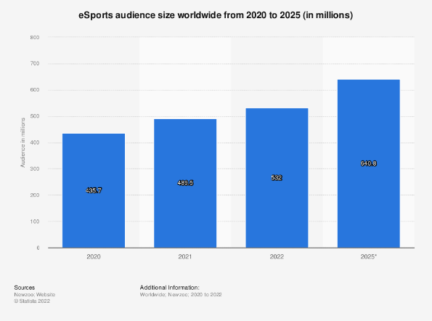

Figure . eSports audience worldwide 2020 - 2025

League of Legends (LoL), published by Riot Games, is regarded as one of the most popular and most proficient eSports games, with over 67 million monthly active players (Yubo Kou et al., 2016). In 2020, an LoL eSports event consisted of over 7,000 professional players, competing for a prize pool of over $79 million (Renkai Ma et al., 2022), with an LoL Championship Finals event in 2018 reaching a viewership of 99.6 million, substantially higher than the NBA finals which averaged 17.7 million (Baber Sabtan et al., 2020).

LoL released a multiplayer online battle arena (MOBA) in 2009, which combines genres of real-time strategy and tower defence-like mechanics. A game of LoL consists of two teams of five players; players can choose 1 of 162 champions, each having a unique playstyle and skill set, with the goal of destroying the enemy team’s nexus (Scott Donaldson, 2017). An application that could predict and analyse these games whilst constantly learning would be a powerful tool for competitive and casual players alike. Whilst many tools analyse LoL games: op.gg, U.gg and LeagueOfGraphs, many of them lack aspects of prediction and approach match prediction by summarising all the player’s win rates on the team to predict the most likely winner of the match.

A game of LoL is a very complex operation - due to the vast different scenarios and outcomes, as well as game times spanning from 30 minutes upwards – with the longest competitive game lasting 1 hour and 34 minutes (Zakaria Almughrabi, 2021). LoL, games can be arduous to predict; a result of the many combinations of different loadouts, champions and objectives that can be used or taken within the game can completely alter the match outcome; mixed with elements of randomness, luck, the skill of players and human behaviour can make predicting games exceptionally challenging. LoL’s back-end servers contain more than 800 features per bm player across millions of players (Ani R et al., 2019); unlike other competitive games, Riot offers an API that stores games, account information and matches statistics temporarily – ideal for collecting large amounts of data, which could be beneficial in predicting constantly changing and varying number of variables important in influencing a match result.

## 1.1 Aims and Objectives

This development project explores the idea that players can learn rapidly from their own performance data by highlighting key features that determine outcomes of LoL matches.

The aims of the project will include:

* Predict league of legends match outcomes.
* Produce meaningful infographics to present users with their stats.
* Allow users to select their own players and champions to run through the machine learning algorithm.
* Allow users to track their progress on a specific champion.
* Allow users to see the current best champions and builds.

The application focuses on using post-game data (teams, ranks, champions and performance) from different LoL games from a variety of different ranks and competitive levels of the game – with the idea of building a constantly evolving data model that a machine-learning algorithm can utilize, due to the complete lack of consistently up to date, LoL match predictors, an application that can constantly evolve as the game receives updates will be necessary at both assessing and predicting what it takes to be successful at higher levels of the game.

## 1.2 Report Structure

This study will achieve its aims by conducting a comprehensive review of previous statistical analytic tools and machine learning approaches adopted, evaluating the performance of various works, and creating a similar tool with added functionality.

Chapter 2 outlines previous work completed: discussing their aims, features, algorithms, and results, as well as exploring alternative match analytical tools currently on the market. This chapter will provide a detailed overview of past research, highlighting any limitations in previous work that can be adopted to aid the development of the application.

Chapter 3 discusses the methodology employed in the development, including the data collection, pre-processing, algorithm benchmarks, database structure and technology used. The benchmark results will be presented in the chapter, along with the feature relationship of the dataset.

Chapter 4 discusses and reviews the results from the machine learning benchmark and the development of the application.

Chapters 5 and 6 discuss the legal and ethical considerations with the development of the application, discussing rules that must be followed when using the Riot API.

Chapter 7 will present the results of this development project and discuss the implications for future work. This chapter will also discuss any limitations or constraints found when developing the application and recommend alternative solutions for further development. This chapter will also mention any time constraints encountered and how they were solved.

## 1.3 Accomplishment

The project compares several machine learning algorithms to find the most appropriate and accurate model for the specific dataset. The project attempted to implement an application that allowed users to input their account and choice of a champion into the model for both a single and team-based predictor, receiving a prediction for their next match. The application also aims to provide the user to monitor their stats through visual graphs and statistical analysis. During the development of the application, the following skills were developed:

* MySQL.
* APIs.
* Frameworks.
* Machine Learning Models.
* Analysing Machine Learning Models.

# **Background**

## 2.1 Related Works

This literature review provides an overview of the previous implementations of machine learning in various projects. The following section provides an oversight into the dataset used, features, machine learning algorithm selection and results of recent implementations of match predictors in LoL, as well as statistical analysis tools already available.

## 2.2 Match Predictors

Ani R (2019) investigated the use of multiple machine learning algorithms: Random Forest, AdaBoost, Gradient Boosting and Extreme Gradient Boosting, achieving the highest score with the Random Forest algorithm, reaching an accuracy of between 95 and 99 per cent. This high accuracy was achieved by implementing the feature “bans”, which recorded the champions that could not be played in the game, and since each champion heavily affects the game by having different abilities, which impacted the model heavily. Other notable features included: champion, summoner spells, role, first blood, gold spent difference, kills, deaths, creep score at 10 minutes, creep score difference at 10 minutes, experience earned at 10 minutes, kills per minute, and towers. The alternative model of in-match concluded features: tower, kills, and deaths were essential features which improved performance. (Ani R et al., 2019)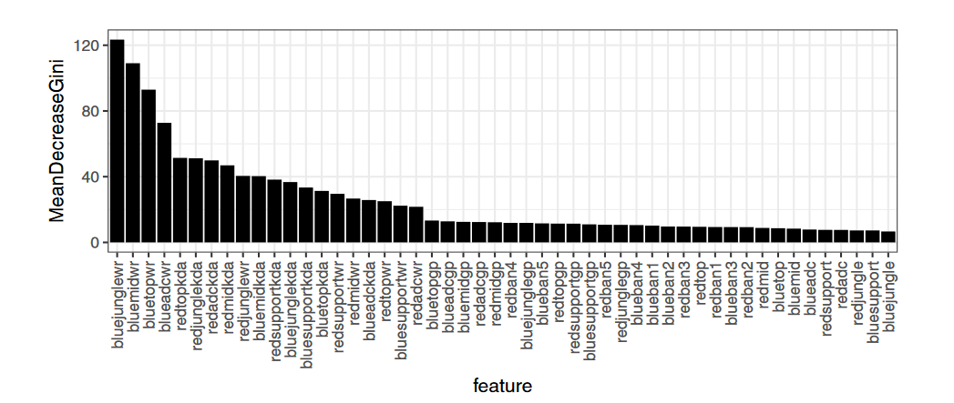

Figure 2.1 Feature Importance (Lincoln Magalhaes Costa et al,2021)

Lincoln Magalhaes Costa (2021) examined the use of ML algorithms in the pre-game phase, combining five datasets containing 2840 professional matches occurring over 2021. These datasets consisted of banned champions, picked champions, and player statistics (games played, win rate and KDA from a given player) – with the final dataset consisting of 51 features. Core features from this dataset consisted of champion selection correlating to the win rate of the selected champion, with the number of games previously played on the selected champion having a negligible impact on the model. The results in Figure 2 showed that the blue jungle laner and bot laner had the most deciding influence on the match outcome. This could be due to the dataset containing an imbalance of blue to red wins, with blue being significantly higher. The study found that the Random Forest, SVM and Linear Regression had the best performance when predicting victories, compared to Naïve Bayes, K-Nearest Neighbour, and Decision Trees – achieving an AOC score of 0.97 when using the RF and LR models. (Lincoln Magalhaes Costa et al., 2019).

Farnod Bahrolollomi (2023) considered implementing fewer features in a machine learning model to predict future match results using an individual’s recent performance. The data from this study was taken from the riot games API, using recent matches as training data for the algorithm. This data used ­features: champion level, lane, total damage dealt, wards placed, physical damage dealt, role, assists, deaths, minions killed, kills, win, runes and first Inhibitor, the most decisive feature for the models as champion level and minions killed. The xgBoost, Gradient boost and RF achieved an accuracy of 92%, with the highest scoring models being the categorical gradient boosting regression and vector regressor, obtaining an accuracy score of 92.98%. However, the study also highlighted the issues with using the limited number of features, focusing more on role selection, with the primary issue being the shift in different statistics promoted by different roles, as support players would have considerably fewer kills than the rest of the team with their focused stats moving towards ward score and crowd control – causing an underprediction of wins in the support category. (Farnod Bahrolollomi et al., 2023)

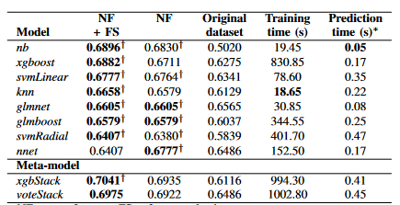

Table . Machine Learning Analysis (Juan Agustin Hitar-Garcia et al, 2022)

A study by Juan Agustın Hitar-Garcıa (2022) took a dataset with 7583 instances, including various games from different leagues and championships played between 2014-2018, processing, consisting of 241 teams, 1470 players and 139 champions. This study included 26 features - a limited number of features as they were primarily based on team composition and individual player win rates rather than delving into in-game statistics that the individual players achieved. This experiment achieved a prediction score of 70% with a meta-model – xgbStack (See Table 2.1), with the most crucial feature within the model being the opposition that the champion was playing against (Juan Agustın Hitar-Garcıa et al., 2022).

## 2.3 Statistical Analysis Tools

Many statistical analytic tools for league of legends currently exist; the most popular include:

* Mobalytics (Mobalytics, 2016)
* LeagueOfGraphs (LeagueOfGraphs, 2013)
* OP.GG (OP.GG, 2012)

These applications offer in-depth statistical reviews through data analysis to highlight areas of improvement for users. These applications highlight champions the user played, kill/death/assist (KDA) ratio, average gold, average minion kills (cs), average game length and more rich information regarding previous and current data, spanning from many previous ranked seasons. (Yubo Kou and Xinning Gui, 2018). These applications then categorize the player by giving them tags, as seen in Figure 2.2, in which the player has positive tags to inform them of their good qualities - many applications like OP.GG and LeagueOfGraphs include live game features, highlighting weaknesses in the opposing teams and the users’ teams, giving the user useful insights which could benefit them over the enemy team if they alter their playstyle to gain an advantage over other players. All applications offer a feature that allows the user to see how they rank against other users on a specific champion by providing a leaderboard on each champion that ranks them based on win rate and KDA. However, these applications do not offer any match prediction capabilities. However, Mobalytics instead uses machine learning to give a player multifaceted player performance, rating a player’s performance in different categories 0-100 based on given statistics from a player to highlight weak or strong areas in a user’s game (Mobalytics, 2016).

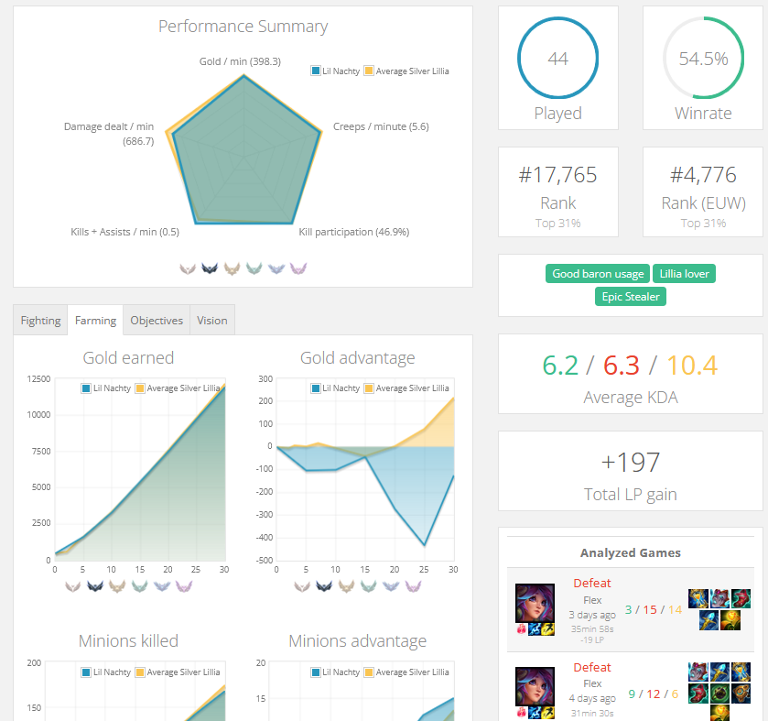

Figure .2 LeagueOfGraphs User Interface

## 2.4 Summary

Overall, previous implementations of match predictors in LoL have been successful using a variety of different features. Most common occurring features include: roles, minions killed, kills, deaths, assists, picked champion, gold earnt, and damage dealt; all important and core features that go into winning a game. The most successful predictors often use random forest and gradient boosting, achieving values of 90% in most cases. The application must also incorporate core statistics and features available in other analytical tools when creating the statistical analysis page; features like match history and infographics commonly occur in other applications are critical in providing the user with feedback of their performance.

# Methodology

During this development project, the intention is to implement an application that can store user statistics from the Riot API into a database. The statistics collected actively from users will be used to train the two separate machine learning models, which will be tested from a selection of five algorithms to find the best algorithm to use in the app. The two separate models will be for individual performance and team performance to predict a match outcome. Users can view these statistics via a Flask web application that processes stats into graphs and demographics. Users can use the application to input scenarios or live matches into the machine learning algorithms by interacting with the application to predict match outcomes. This project will incorporate the waterfall model; time management can be found in Appendix J. Design data such as flow charts, entity relationship diagrams, UML and use case diagrams can be found within Appendix E and F.

## 3.1 Requirement Analysis

Requirements were decided by investigating pre-existing applications shown in Chapter 2. These applications offer extensive functionality and provide a foundation for the application to build on, extending them by adding machine learning capabilities.

Table E.1 outlines the Functional requirements for the app. The application should integrate with both the riot API and data dragon API, which is crucial for getting data and pairing IDs across datasets to access images, champion details and user statistics. The application should also allow players access to past games, with detailed infographics in the form of graphs to show progression. The app should show users champions showing item and rune build recommendations and statistics as well as their specific stats on a given champion. The app should be able to make predictions; in scenario based-matches, live games and for a specific user.

Table E.2 outlines Non-functional requirements. The application should be able to make predictions accurately to get the best possible match outcomes for users. The application must be easily intuitive for users, being easy to navigate to different pages and absorb information seemly. The application should be available in any location and must provide features for different regions. The application must also be useable and perform when handling multiple users, providing statistics from the database when the API key is unavailable.

Wireframes were heavily influenced on existing applications discussed in Chapter 2. This was to give users familiarity when using the application. Wireframes can be found in Appendix G Figures G.1, G.2, G.3, G.4, G.5.

## 3.2 APIs

Both Riot Games API and DataDragon API will be used to get summoner stats, assets, and champion details.

### 3.2a Riot Games API

Riot Games offers a public API endpoint. When accessed, data can be provided on various game-related information, such as summoner details, summoner match history, mastery levels and in-depth match stats sorted in minutes (Lucas Lin, 2016). Riot API developer key allows for 20 requests every 1 second, or 100 requests every 2 minutes, limited to each region (NA1, EUW, Americas); however, summoner match history is only stored temporarily. As the user plays games, the endpoint updates with more recent entries.

### 3.2b DataDragon API

DataDragon is a collection of static files that provides the latest images and information regarding champions, runes, and items. This API is vital for translating IDs into useful information regarding champions, items, and images – providing the latest version alongside the game updates (Riot API Libraries, 2022). Community Dragon is a community-run collection built from data dragon, in which a more significant number of files and alternative image files can be found (Riot API Libraries, 2022). Both libraries will be essential for the development of the application, making it easy to translate IDs into images that can be used to allow the user to interpret statistics of a given item or champion by providing images.

## 3.3 Frameworks

Frameworks are a collection of pre-written code and libraries that provide a foundation for developing applications. Frameworks can provide extra functionality, templates, and security to a code base, which makes implementing one allow the project to focus on the higher-level functionality of the application (Vijay Sigh Khatri, 2022). The application made use of the Flask Framework to run server operations and serve HTML templates to the user. The Bulma framework was used to provide visual components and UI consistency throughout the application.

### 3.3a Flask

Flask is a lightweight, flexible, and open-source Python framework used for building web applications. Flask provides built-in functionality for databases, mail services and authentication, with many more Flask extensions available to be added when the application needs it (Adbelhadi Dyouri, 2020). Flask uses the Jinja template engine to serve HTML pages, incorporating coding concepts like variables, loops and lists into the HTML, offering the ability to iterate over objects and set variables within the HTML without JavaScript (Adbelhadi Dyouri, 2020). Flask was selected over other popular frameworks like Django, as it was more efficient to integrate databases into Flask using the inbuilt flask extensions, as well as having the flexibility to add to the much smaller stack with Flask than add more extensions onto Django (Vijay Singh Khatri and Robert Johns, 2023). The application has no need to be secure, as only publicly available stats are being stored; this meant that Django’s extra security functionality (Vijay Singh Khatri and Robert Johns, 2023) was not needed, as there is no account or authentication service required. The application will be a single-page application, which is more suited towards Flask; its small code base and scalability allow for quicker development but do not offer the maintainability of Django. (Vijay Singh Khatri and Robert Johns, 2023)

### 3.3b Bulma

Bulma is an open-source CSS framework used to add extra functionality when building user interfaces, adding custom class components like forms, buttons, navigation bars, grids, and cards (Hanneh Kalio, 2023). Bulma is a lightweight, simple, and highly customizable framework backed by comprehensive documentation, but it lacks community support since it is a new framework (Jamie Juviler, 2022). Bulma was selected over Bootstrap due to its simplicity, with many different classes and has more straightforward naming conventions. Bootstrap requires a lot more time to become familiar with all the different customization options and complex naming conventions (Hanneh Kalio, 2023). Bootstrap also is more heavily dependent on JavaScript functionality (Jamie Juviler, 2022); when added to the time constraint of learning both a new framework and JavaScript, the extra workload of learning a new language could be a risk to the project.

## 3.4 Database

The database implements a MariaDB server. The server has 2MB of data, consisting of 8 tables. MariaDB was chosen as an open-source alternative to MySQL, introducing many benefits over MySQL by allowing database loads to be split onto several servers for optimization and scaling (MariaDB, n.d). If the application expands to heavy user loads, then scaling the database will be necessary for the application to expand in the future. MariaDB also offers enhanced performance, beating MySQL in both query speed and the ability of supported running of thread pools which can support thousands of different connections concurrently (Shahzeb Ahmed, 2022).

### 3.4a Normalisation

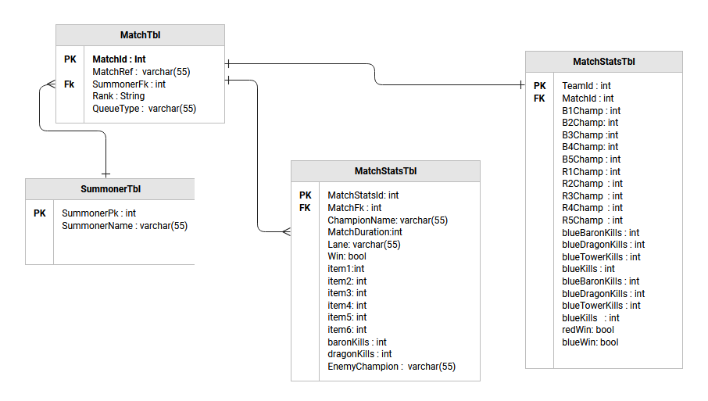

Figure 3.1 ERD Before Normalization

Figure 3.1 shows an ERD before the database was normalized; the table originally stored a new matchID for every summoner; if every summoner in the game had their data recorded, then the MatchRef would have reoccurring values for both match reference, queue type and rank. To prevent this, as seen in Figure E.1, the SummonerMatchTbl was introduced. This would ensure that there was only one unique entry for MatchID, rank, and queue type – referencing MatchID in the SummonerMatchTbl and pairing it with a summonerID and championID to signify the summoner and champion name that a specific user played in that game. Champion, item, and rank tables were also introduced in the normalization progress. This meant that instead of repeating string values – they were all assigned IDs to prevent repetitive entries and data loss.

Mastery points are an integer that represents how experienced a player is on a given champion. Mastery points are added to a summoner's account for every game played by a champion. The more a user wins games, the more mastery points they gain on a champion (Tiffany Do et al., 2021). Due to the Mastery points endpoint constantly changing as users play games, the need for it to be stored is minimal, as the data will constantly need to be altered to ensure it is up to date – as well as constantly being stored under an existing endpoint from the Riot API, creating a table to store it under will waste resources. For a machine learning algorithm to take into consideration the amount of experience the user has on a given champion, the current mastery points value correlates to the value of mastery points the user had at the time of data collection. The other data points in the table were selected due to being valued previously as fundamental variables within a match, with items and runes being selected for data collection for the purpose of the application rather than features for machine learning.

## 3.5 Data Collection

To gather data, a script was created to query a single summoner, gathering in-depth statistics in their last 15 matches. This script gathered important match details, including match result, kills, damage, deaths, assists, and loadout. The data is also being actively gathered as users search for their own or others’ summoner usernames; upon being queried, new entries are added to the database and stored by match.

### 3.5a Dataset

Both datasets are compiled from data from both the match stats and team match table (see Tables F.1 and F.2). All the data points from the team match table are used within the algorithm as features for the team predictor. For the Solo match predictor, the following features are used:

* Champion played.
* Minion kills.
* KDA
* Lane.
* Damage dealt.
* Damage taken.
* Turret dmg dealt.
* Total gold
* Enemy champion played.
* Game duration
* Dragon kills.
* Baron kills.
* Win.

Data points within the table regarding items and runes were left out of the model; to use these features, an extensive amount of data would require for each champion for the model to be accurate. Many features previously discussed within Chapter 2 are used; reoccurring features like damage dealt and taken, gold, boron, KDA and dragons are previously regarded as essential features, providing models with successful results in the past. The dataset only uses games that took place on ranked or unranked Summoner’s Rift instead of any other game mode. Values that contained string values were translated to IDs using Data Dragon API.

### 3.5b Dataset Analysis

|  |  |  |  |  |  |  |  |  |  |  |  |  |  |  |  |
| --- | --- | --- | --- | --- | --- | --- | --- | --- | --- | --- | --- | --- | --- | --- | --- |
| ChampionFk | CS | K | D | A | Lane | MasteryPoints | DmgDealt | DmgT | TK | Gold | EnemyFk | GameLen gth | DK | BK | W |
| 221 | 326 | 10 | 9 | 3 | 3 | 8170 | 63303 | 35236 | 2 | 18558 | 238 | 2152 | 0 | 0 | 1 |
| 360 | 218 | 16 | 4 | 3 | 3 | 31641 | 47306 | 23165 | 6 | 16437 | 498 | 1447 | 0 | 0 | 1 |
| 360 | 204 | 27 | 4 | 3 | 3 | 31641 | 47987 | 23213 | 6 | 18909 | 110 | 1436 | 0 | 0 | 1 |
| 19 | 98 | 12 | 1 | 1 | 1 | 8089 | 36262 | 58653 | 2 | 16051 | 154 | 2170 | 1 | 0 | 0 |
| 676 | 128 | 4 | 6 | 1 | 1 | 13632 | 7727 | 21609 | 0 | 9145 | 19 | 1303 | 0 | 0 | 0 |

Table 3.1 Head of Dataset for Solo Predictor

|  |  |  |  |  |  |  |  |  |  |  |  |  |  |  |  |  |  |  |  |  |  |  |
| --- | --- | --- | --- | --- | --- | --- | --- | --- | --- | --- | --- | --- | --- | --- | --- | --- | --- | --- | --- | --- | --- | --- |
| *B1* |  | *B2* | *B3* | *B4* | *B5* | *R1* | *R2* | *R3* | *R4* | *R5* | *BBK* | *BRHK* | *BDK* | *BTK* | *BK* | *RBK* | *RRHK* | *RDK* | *RTK* | *RK* | *RW* | *BW* |
| 79 |  | 2 | 245 | 221 | 238 | 31 | 19 | 55 | 498 | 40 | 0 | 0 | 2 | 5 | 33 | 2 | 2 | 3 | 9 | 47 | 1 | 0 |
| 122 |  | 35 | 38 | 498 | 497 | 2 | 30 | 80 | 360 | 412 | 0 | 1 | 0 | 2 | 19 | 1 | 1 | 3 | 11 | 36 | 1 | 0 |
| 516 |  | 79 | 157 | 110 | 40 | 98 | 141 | 136 | 360 | 497 | 0 | 1 | 0 | 1 | 18 | 0 | 1 | 2 | 9 | 38 | 1 | 0 |
| 517 |  | 59 | 157 | 221 | 40 | 133 | 104 | 79 | 51 | 99 | 1 | 0 | 2 | 5 | 31 | 2 | 1 | 4 | 9 | 45 | 1 | 0 |
| 57 |  | 83 | 895 | 711 | 19 | 875 | 154 | 43 | 498 | 8 | 0 | 2 | 1 | 9 | 39 | 1 | 0 | 4 | 8 | 57 | 1 | 0 |

Table 3.2 Head of Dataset for Team Predictor

Many factors could affect the quality of the dataset; factors like trolls or smurfs could influence the dataset negatively; trolls are players that deliberately go out of their way to negatively impact the performance of their team or try to throw the game (Christine Cook et al.,2019). In an instance where a specific player/team captured many objectives and had high kills but still did not destroy the opposing team's nexus due to a player on the team sabotaging or not participating, they are more likely to lose the game. A scenario like this could negatively impact the model as a player with high statistics still lost the game. Smurfs create new accounts to play against lower rank players; these players can significantly influence the match, outperforming everyone in the match (Yubo Kou et al., 2018). Both factors above will have adverse outcomes on the dataset, inflating the values it takes to succeed in the game, which could hinder lower-ranked players' predictions when using the model.

Table 3.1 shows the first five rows of the solo predictor, the values indicating to championId, minions killed, kda, lane, mastery points, dmg dealt, dmg taken, turrets killed, gold, enemy champion, game duration, baron kills, dragon kills and if the user won that match. The table shows a variety of different data points, with more positives cases pointing to wins, in which the user had high mastery,damage given and low damage dealt, which will be important when training the model.

Tables 3.2 shows the First 5 rows for team dataset, B1-5 and R1-5 represents blue champions and red champions by championID, with the rest of the values corrallating to baron wins, dragon wins, team kills and rift hearalds, with the last two collumns indicating to a blue win or red win.

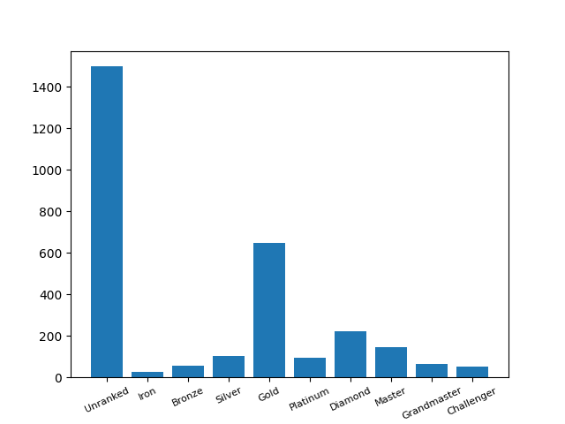

Figure . Distribution of Ranks

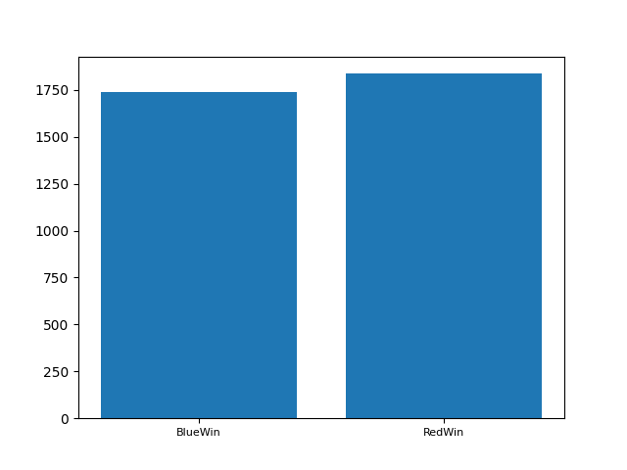

Figure . Distribution of wins

When testing different models, the dataset consisted of 3577 matches with 4706 match statistics collected, with red wins totalling 1,837 and blue wins totalling 1,740. Figure 3.2 shows the distribution of ranks across wins in the dataset. However, unranked contains the highest number of entries – the match was likely to be played among the higher ranks, but one or more players in the game did not have a rank at the time of data collection. The most common rank data was collected at gold, followed by diamond, which could affect lower-ranked players' statistics when using the model, as lower or new-ranked players could do less at their rank to win any game due to the skill required to play at each level. Figure 3.3 shows the red vs blue side wins, the red side having a slightly larger number of wins which could potentially lead to a slight bias of predicting the red side more than the blue produced by inconsistencies when collecting data.

## 3.6 Algorithm Selection

The machine learning algorithms below were chosen from previous work. The Random Forest, xgBoost, AdaBoost (Ani R et al., 2019), and SVM (Lincoln Magalhaes Costa et al., 2021) have all been used in previous research in the field of LoL match prediction – all boosting positive results previously. The most successful is the Random Forest algorithm, usually achieving 78-95% depending on the dataset. The gradient boosting algorithm was selected due to an accuracy of ~92% in a previous study (Farnod Bahrolollomi et al., 2023). Naïve Bayes has been previously selected in numerous studies in match prediction with steady results in both (Qiyuan Shen, 2022) and (Jaun Agustin et al., 2021), achieving 68% - 72%. A benchmark comparison process will be performed to select a suitable algorithm from those mentioned above.

The benchmark test will use the classification report from the sklearn library to find the accuracy score, log loss, mean square error, recall and f1-score. Each model will also be compared by assessing the ROC curve. To analyse features within the model, the Seaborn library will plot heatmaps to find relationships between features. The algorithms will use a test data set size of 25% of the dataset. Based on previous work, the random forest algorithm is expected to perform best, followed by the xgBoost, AdaBoost and Gradient Boost, which have all shown promising results when working with a binary classification problem. The random forest is expected to outperform the other algorithms due to its robustness to noise (Robert E.Shapire, 2001) and the model’s ability to be less influenced by random variations or anomalies within the dataset. The algorithm expected to underperform is the Naive Bayes due to its previous performance in the field; whilst also primarily applied when utilising text-based prediction rather than binary classification can still be effective but, in the case of match prediction, may not be effective as Naïve Bayes assumes that all features are conditionally independent (Kevin P Murphy, 2006).

## 3.6a Algorithms

**Random Forest**: Random Forest is a supervised machine learning algorithm which uses a decision tree predictor – combining the output of multiple branches to get a more accurate and reliable prediction. (Ani R et al., 2019).

**xgBoost**: xgBoost is a supervised machine learning algorithm – a variation of random forest that uses meta-learning to boost individual decision trees rather than providing a selection of random trees (Victoria J. Hodge et al., 2021).

**SVM**: Support Vector Machine is a supervised machine learning model that classifies data using a linear or hyperplane model. This decision boundary separates the data points to avoid overfitting the model resulting in more accurate results (Madan Somvanshi et al., 2016).

**Naïve Bayes algorithm**: Naïve Bayes is a classifier that probabilistically classifies data by applying Bayes’ theorem with independent connections between features (K.Vembandasamy et al., 2015) - its accuracy is generated by assuming that all attributes are separate from each other, providing the need to estimate multiple probabilities across different variables (Shenglei Chen et al., 2020).

**AdaBoost**: AdaBoost is a meta-learning method designed to increase the accuracy of classifiers by combining weaker classifiers into a single robust classifier by learning from mistakes in the weak classifiers (Ani R et al., 2019).

**Gradient Boosting Classifier**: Gradient Boosting is a supervised learning algorithm. Gradient Boosting aims to improve prediction accuracy by using decision trees, where newly added trees can learn from the previous mistakes of each iteration (Quang Hieu Vu et al., 2021).

## 3.7 Solo Predictor

|  |  |  |  |  |  |  |  |
| --- | --- | --- | --- | --- | --- | --- | --- |
| Methods | Binary | Prediction Rate | Recall | F1-score | Support | Mean Square Error | Log Loss |
| Random Forest | 0  1  AVG | 87.40%  88.30%  87.85% | 0.85  0.89  0.87 | 0.87  0.89  0.88 | 595  688  1283 | 0.12 | 0.31 |
| xgBoost | 0  1  AVG | 85%  83%  84% | 0.81  0.87  0.84 | 0.83  0.84  0.84 | 615  678  1283 | 0.15 | 0.41 |
| SVM | 0  1  AVG | 84.44%  87.66%  86.55% | 0.85  0.86  0.86 | 0.85  0.87  0.86 | 594  689  1283 | 0.15 | 0.72 |
| AdaBoost | 0  1  AVG | 82%  86%  84% | 0.84  0.84  0.84 | 0.83  0.84  0.84 | 605  678  1283 | 0.17 | 0.67 |
| Naïve Bayes | 0  1  AVG | 70.50%  84%  77.25% | 0.84  0.68  0.77 | 0.77  0.77  0.77 | 605  678  1283 | 0.22 | 0.55 |
| Gradient Boosting  Classifier | 0  1  AVG | 82.5%  85.50%  84.40% | 0.83  0.84  0.84 | 0.83  0.85  0.84 | 605  678  1283 | 0.15 | 0.37 |

Table 3.3 Solo Predictor Results (Average over five Runs)

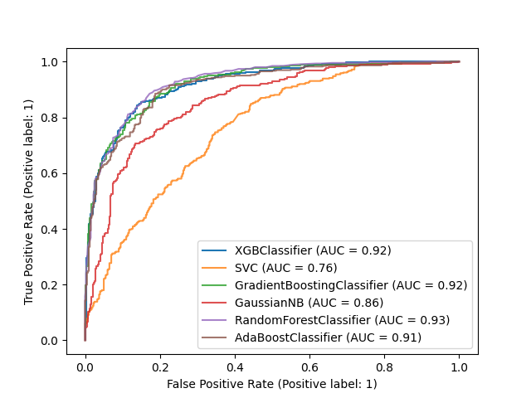

Figure . Solo Predictor AUC

## **3.8 Team Predictor**

To implement the team predictor, the multioutput classifier was implemented into each algorithm. This allowed the model to predict two target variables (blue or red win) rather than the previous one seen in the solo predictor.

|  |  |  |  |  |  |  |
| --- | --- | --- | --- | --- | --- | --- |
| Methods | Binary | Prediction Rate | Recall | F1-score | Support | Mean Square Error |
| Random Forest | 0  1  AVG | 97%  96.60%  96.80% | 0.96  0.96  0.96 | 0.97  0.97  0.97 | 447  448  895 | 0.03 |
| xgBoost | 0  1  AVG | 95.33%  92..33%  93.83% | 0.92  0.95  0.93 | 0.93  0.94  0.94 | 457  438  495 | 0.06 |
| SVM | 0  1  AVG | 86.66%  83.66%  85.15% | 0.82  0.84  0.84 | 0.84  0.86  0.85 | 435  460  495 | 0.14 |
| AdaBoost | 0  1  AVG | 96.66%  95.66%  96.16% | 0.96  0.96  0.96 | 0.96  0.97  0.97 | 460  435  495 | 0.03 |
| Naïve Bayes Algorithm | 0  1  AVG | 95.66%  93.66%  94.66% | 0.93  0.95  0.94 | 0.95  0.95  0.95 | 460  435  495 | 0.04 |
| Gradient Boosting  Classifier | 0  1  AVG | 96%  96%  96% | 0.96  0.96  0.96 | 0.95  0.96  0.95 | 456  439  495 | 0.04 |

Table 3.4 Team Predictor Results (Average over five Runs)

## 3.9 Feature Importance

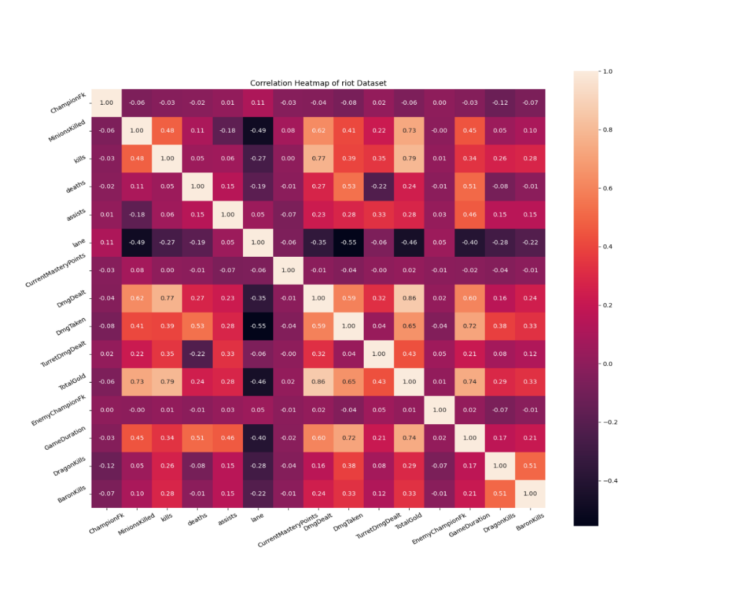

Figure 3.5 Feature Importance Solo Model Heatmap

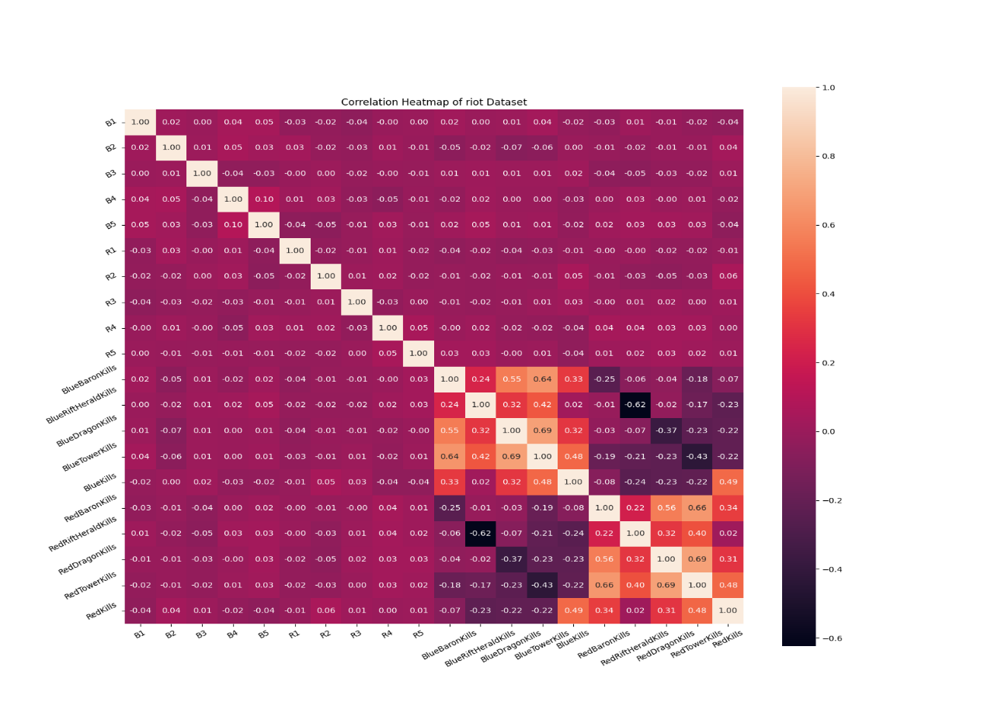

Figure 3.6 Feature Importance Team Model Heatmap

## 3.10 Testing

To test the program, PyTest was used to ensure that the application's core components were operational. Testing was split into multiple different parts, endpoint, database, and API. On top of the previous benchmark, further machine learning testing was undergone to ensure the program produced meaningful, accurate predictions.

Endpoint testing consisted of testing the application's different links for a response code of 200; each HTML page on the website was tested for either a 200 response or a JSON response if the endpoint returned predictions, see Table H.4. Existing POST and GET methods were tested using pythons request library.

Database testing, found in Table H.2, consisted of testing queries used in the program, this would ensure that query results were accurately processed and returned from the database.

API testing was done to ensure that the program correctly implemented both Riot API and DataDragon API into the program. This would ensure the program's API key and functionality are operational; for the entire testing, see Table H.1.

Machine learning testing, seen in Table H.5, shows negative and positive cases; both instances of users that should win games were passed through the machine learning models to see if the model creates accurate results on different scenarios.

Accessibility Testing, presented in Table H.3, was the process of using an external site to improve accessibility; testing was undergone by hosting the server and passing the links into Siteimprove.com to gain feedback on additional settings that could make the site more accessible. (Siteimprove, 2023).

# Results

The project aimed to create an application that could accurately predict and analyse LoL Matches. This section will discuss results from the undergone machine learning benchmark and review the program created.

## 4.1 Solo Predictor

Table 3.3 shows the model performance of the solo predictor; an accuracy of 87.85% was achieved using Random Forest; the algorithm also achieved the lowest log loss score, indicating it had a reliable and accurate prediction. Random Forest also achieved the highest AUC score of 0.92 (See Figure 3,4), indicating a solid ability to classify both wins and loses instances – as well as the highest recall of 0.87, suggesting a lower rate of false negatives or false positives. SVM had the second-highest rate of prediction, boasting an accuracy of 86.55%. Despite this high score, the model had a log loss of 0.72, which could hint at the model performing inadequately when predicting probabilities, potentially caused by feature selection, overfitting and underfitting of the training dataset. xgBoost, AdaBoost and Gradient Boosting all performed similarly, achieving 84% accuracy – with the Gradient Boosting regarded as the best model due to it achieving the lowest log loss score and a joint mean square error of 0.15 with xgBoost. Both xgBoost and AdaBoost had apprehensive predictions compared to other algorithms in the test; due to the high log loss, the models are likely to produce undesirable predictions. The high log loss score makes it inadequate for the application; valued predictions would often be inaccurate and low value. The Naïve Bayes algorithm performed the worst, achieving an accuracy of 79.52% and a recall of 0.77. The model predicted false wins more often than other algorithms. The model also had a high log loss, making it substandard compared to other models – often predicting false wins and inaccurate results. The Random Forest algorithm will be used in the application for the solo predictor because it outperforms other algorithms by upwards of 4% whilst also having the best ROC curve, making its predictions accurate and meaningful.

Figure 3.5 illustrates a heatmap displaying features: total gold, damage dealt, kills, minions killed, and game duration. These features have a noticeable relationship with wins, with features like total gold and damage dealt having the most impact on the dataset – both core features to consider when predicting an outcome of the game. Whilst other features are expected to have a strong relationship with wins, features such as dragon kills, baron kills, and turret damage had a lesser influence on the model. However, the relationship is much stronger when a summoner takes both dragon and baron kills. Notably, kills and turret damage had a relationship of 0.35, a negligible relationship compared to previous experiments, in which they were the most influencing factors in the dataset (Ani R et al., 2019). Features like champion selection, enemy selection and mastery score offered little influence when correlating to wins, also seen in a previous experiment in which the summoner's experience with a champion's had minimal impact on the model. (Lincoln Magalhaes Costa et al, 2021). This could result from a lack of data on all given champions, as there are only 4,706 rows in the dataset and each champion would need a significant amount of data before the model starts to generalize weak matchups and stronger matchups for any given champion. Since the model was influenced by kills, minions killed and gold earnt, the model may be ineffective in supporting players; these players typically have a higher number of assists and a lower number of kills and total gold.

## 4.2 Team Predictor

Table 3.4 shows the model performance of the team predictor, with accuracies ranging from 86% to 96%. The Random Forest performed the best out of the machine learning models attaining a prediction rate of 96.80% - slightly higher than Gradient Boost. The Random Forest attains a higher F1 score, recall and mean square error than Gradient Boost, making it slightly more effective. However, the SVM model, despite the previous performance in the solo predictor, performed the worst out of all the models. The SVM model achieved an accuracy of 85.15%, around 11% lower than all the other models. The SVM model also had the highest mean square error of 0.14, around 0.08 points higher than xgBoost, making it the substandard model for this specific dataset which will not be used in the application. The Naïve Bayes, Gradient Boost and AdaBoost all performed similarly, achieving accuracies of around 94% - 96%. The AdaBoost was the closest to matching the Random Forest, nearing the same scores, with both algorithms performing near the same performance-wise, but Random Forest was slightly more accurate. The Naive Bayes was the 3rd best-performing algorithm, predicting both 1 and 0 classifications with a 96% accuracy, which was the only model that had the same prediction rate for both values. However, the model was bested by the Random Forest in prediction rate and a mean square error of 0.01, making it minimally less effective. The xgBoost was the 2nd worst-performing algorithm, achieving an accuracy of 93.83% and a mean square error of 0.03. Random Forest algorithm will be used in the application for the team predictor because it outperforms other algorithms slightly, ensuring users have the most accurate and precise predictions.

Figure 3.6 demonstrates the relationships between features in the team model. Features like baron kills, dragon kills, and tower kills had strong relationships with a win, all critical and match-altering factors, with the most vital relationship being shared with the team who took the most dragons and turrets. From the figure, both teams' feature importance varied slightly; from the blue side, the chance of winning a game when taking heralds and dragons where 0.02 higher than seen on the red. When measuring the red side, the baron kills seemed to be more influenced when taking kills, turrets, and dragons. The model was also influenced by kills showing a 0.49 relationship between blue kills and red kills while killing more players than the enemy team is essential; it is unnecessary to win the game (Marçal Mora-Cantallops and Miguel-Angel Sicilia, 2019). The score of 0.49 reflects the statement accurately; a team with a noticeable kill difference is most likely to win the game, as they have claimed more gold than the other team – which can be used to take control of the other objectives; alternatively, a scenario where kills are much closer can still leave most of the map open for the team with fewer kills to take objectives and still be successful in the game. Often a red and blue correlating feature had a detrimental effect on the model, usually because the red team claiming a turret whilst the blue team claimed a dragon would not correlate to any team taking advantage as the blue team could waste the baron or the red team could go on to claim no other objectives.

## 4.3 Application

The application successfully implemented a Flask web application that can accurately predict games based on a user's previous matches, mastery score, champion and role selected; the app has three prediction settings. This first setting consists of a one-versus-one match-up, in which a user can input their name, champion, enemy champion and role to predict a match. The other settings include a live game predictor and a match predictor, where the variables of all team members are summarised into the team predictor model to return the user with a prediction variable.

However, the application suffers heavily from an API limit, which currently only supports a low user base, only offering the application to search for 15 users every 2 minutes. The match prediction side of the application is heavily biased against support players'; this is due to their role in the team having a lesser effect on gold earnt and kills, which are regarded as essential features of the model which could be fixed as the application is used and collects more support games. The application also has no in-depth details on individual matches like other tools have, which is due to a table in the database being removed in development due to it using a large amount of space; this table stored JSON, which eventually took up a large amount of storage. Removing this table meant that in-depth statistics and minute-by-minute comparisons could not be implemented. The application is currently more tailored for users in Europe; many features, like match prediction and live games, cannot be viewed by players outside of Europe due to time constraints. The application also needs better performance issues like slow load times and heavy delays will only scale with users. The final user interface design was altered slightly from the Wireframes in Appendix G, the match predictors were re-designed to mimic the in-game champion select that LoL has, the user can select roles using images rather than forms usually found in websites.

### ****4.3a Achievement****

Table J.2 outlines previously defined requirements based on if the requirement has been fulfilled. Overall, many of the requirements had been met; the application can predict live games, made-up scenarios, and individual performance based on users' LoL accounts accurately. The application also presents users' stats clearly, using infographics and data processing to present previous matches. However, the application falls short compared to other analytical tools; it cannot review specific games a user played and present minute-by-minute data on match events, nor can it allow players to compare their stats with other players. Although, the application does add the functionality of match prediction, which isn't present in popular LoL analytical tools. The application also falls short on both localisation and user capacity; whilst it can allow players from other regions, not all features like match prediction are supported.

### 4.3b Project Timeline Review

The Gannt chart outlined in Figure J.1 was followed closely; however, issues that arose whilst undertaking the project increased the duration of specific tasks. The main issue was the data store, which was revisited as seen in Table J.1, as the datastore was resource-heavy, storing duplicate values and whole matches as JSON. Due to the loss of whole matches, more data points were added to the table, so the ERD and database development were revisited. This pivotal point in development was responsible for missing out on the last few requirements. Due to spending more time and resources on implementing the database and machine learning models, essential aspects like advanced infographics, user interface tuning, and specific match data could not be implemented.

Overall, the project incorporated the waterfall model effectively to plan and analyse other software projects and programs to build program structure and flow charts and develop and test the program. These practices successfully ensured that the project flowed smoothly overall and built a software project that fulfilled many of the outlined requirements.

# **5. Legal Considerations Chapter**

The application has no requirement to store sensitive information. The only identifiable data is a username, available publicly and shown within a game of LoL, which cannot be traced back to email addresses identifying the player. The application will also need to follow Intellectual Property laws and respect the IP of Riot Games; whilst Riot offer many assets for use within application development, it is vital to follow rules they have set when developing the application to avoid any legal complications. This application is also non-commercial; using LoL’s IP to benefit for financial gain could breach copyright or trademark laws.

## 5.1 Developer API Policy

When using the Riot API for developing applications, the application must abide by the following:

* Products must be in line with laws.
* Games cannot be developed using Riots Intellectually property.
* No cryptocurrencies or blockchains
* Products must not resemble Riot’s games or products in functionality or style.
* You must post the following legal boilerplate to your product in a location that is readily visible to players:
  + [Your Product Name] is not endorsed by Riot Games and does not reflect the views or opinions of Riot Games or anyone officially involved in producing or managing Riot Games properties. Riot Games and all associated properties are trademarks or registered trademarks of Riot Games, Inc

(Riot Games, 2022)

The product is also registered with riot games to ensure the licence key stays up to date; when registered, the product must comply with the legal rules above. The application does not build any games, use cryptocurrencies, and does not resemble any existing Riot games products. The boilerplate can also be footer of each page.

# 6. Ethical Considerations Chapter

The application will have to inform users of its data collection. However, it does not collect sensitive data; it is crucial to be transparent with the user (Karen Rodham & Jeff Gavin, 2006) to provide information on how their Riot Games account name and statistical information are stored. The application will have to respect the intellectual property of LoL, the LoL development portal outlines the following:

* Products cannot be used to create an advantage for players, like cheating or any form of advantage that a player without the application may not have.
* Products should not influence players to decrease diversity within game, limiting builds, team compositions and characters.
* Products should not create alternatives to official ranking systems within a game.
* Products should not remove game decisions – but can highlight important moments and give multiple choices for a player to make an informed decision.

(Riot Games, 2022)

The application does not create an unfair advantage as it only predicts an outcome which is not certain; a player without the application will face no disadvantage to a player using the application within a specific game. The tool is merely a form of predicting which team is more likely to win a game, given a set of inputs. The application does not influence players to select different builds; instead informs them on the most popular or highest winning builds, items, and champions – but does not force them to select these paths. The application reflects the ranking system used within League of Legends rather than creating its own. The product has no feature that highlights important moments in the game.

# 7. Conclusion Chapter

This project introduced a web application that can analyse and predict LoL games accurately. High accuracies of 88% - 96% were achieved using Random Forest across two separate match prediction tools using players' or teams' previous statistics using a limited number of features. The application can predict LoL matches with excellent efficiency, and the user interface is intuitive and allows users to select input variables and receive a match prediction. The code base provides a sturdy foundation for further development – being maintainable, extendable, and easily deployable due to the technologies like Flask and docker implementation.

Future work includes implementing a database with more extensive storage, training the model using support-only data when support is selected, and becoming more reliant on the database rather than Riot's API to improve performance and scalability. To improve accuracy, a deep learning model could be implemented; this would be able to find more complex patterns in the data. Deep learning could be used to analyse a larger dataset and learn from raw data, which could make inputting build paths, runes, and summoner spells more meaningful in a different approach rather than using machine learning. However, it is important to note that no predictor can be 100%; external factors like players' throwing games or performing inconsistently will have a significant influence on the predictor's results.

Overall, the LoL application produced has the potential to be a powerful tool used for both casual and professional players to find weaknesses within games, find fitting team compositions based on a group of specific players and predict live games effectively. Future work and development of the application can address current limitations to improve accuracy, analytical improvements, and usefulness.

# 8. References

Riot games. developer of league of legends, valorant, teamfight tactics, legends of Runeterra, and wild rift. creators of arcane. home of lol and Valorant Esports. (no date) Riot Games. Available at: https://www.riotgames.com/ (Accessed: October 20, 2022).

Hitar-Garcia, J.A., Moran-Fernandez, L. and Bolon-Canedo, V. (2022) Machine learning methods for predicting league of legends game outcome. IEEE Transactions on Games.

Gough, C. (2023) *Global Esports Audience 2020*, *Statista*. Available at: https://www.statista.com/statistics/1109956/global-esports-audience/ (Accessed: January 2, 2023).

Jang, W.W. and Byon, K.K. (2021) Investigation of eSports Playing Intention Formation: The Moderating Impact of Gender. Sport Marketing Quarterly, 30(3).

Sarlis, V. and Tjortjis, C. (2020) Sports analytics—Evaluation of basketball players and team performance. Information Systems, 93, p.101562.

Agrawal, M. and Upadhyay, A.K. (2022) Understanding esports industry and impact of Covid-19 on it: a review of literature. Cardiometry, (22), pp.371-376.

Ani, R., Harikumar, V., Devan, A.K., & Deepa, O.S. (2019). Victory prediction in League of Legends using feature selection and ensemble methods. In International Conference on Intelligent Computing and Control Systems (ICCS) (pp. 74-77). IEEE.

Donaldson, S. (2017). Mechanics and metagame: Exploring binary expertise in League of Legends. Games and Culture, 12(5), 426-444.

Kou, Y., Gui, X., & Kow, Y.M. (2016). Ranking practices and distinction in League of Legends. In Proceedings of the 2016 Annual Symposium on Computer-Human Interaction in Play (pp. 4-9).

Ma, R., Gui, X., & Kou, Y. (2022). Esports Governance: An Analysis of Rule Enforcement in League of Legends. Proceedings of the ACM on Human-Computer Interaction, 6(CSCW2), 1-28.

Maymin, P.Z. (2021). Smart kills and worthless deaths: Esports analytics for League of Legends. Journal of Quantitative Analysis in Sports, 17(1), 11-27.

Lin, L. (2016). League of Legends match outcome prediction. Computer Science Department, Stanford University, Stanford, CA, USA, Report.

Do, T.D., Wang, S.I., Yu, D.S., McMillian, M.G., and McMahan, R.P. (2021). Using machine learning to predict game outcomes based on player-champion experience in League of Legends. Proceedings of the 16th International Conference on the Foundations of Digital Games, 1-5.

Hodge, V.J., Devlin, S., Sephton, N., Block, F., Cowling, P.I., and Drachen, A. (2019). Win prediction in multiplayer esports: Live professional match prediction. IEEE Transactions on Games, 13(4), 368-379.

*JS for Bulma Tabs - CodePen* (no date) *CodePen*. Available at: https://codepen.io/t7team/pen/ZowdRN (Accessed: 2023).

JSFiddle (no date) *JSFiddle*. Available at: http://jsfiddle.net/UNs9J/1/ (Accessed: 2023).

Vembandasamy, K., Sasipriya, R., and Deepa, E. (2015). Heart diseases detection using Naive Bayes algorithm. International Journal of Innovative Science, Engineering & Technology, 2(9), 441-444.

Chen, S., Webb, G.I., Liu, L., and Ma, X. (2020). A novel selective naïve Bayes algorithm. Knowledge-Based Systems, 192, 105361.

Maulud, D., and Abdulazeez, A.M. (2020). A review on linear regression comprehensive in machine learning. Journal of Applied Science and Technology Trends, 1(4), 140-147.

Somvanshi, M., Chavan, P., Tambade, S., and Shinde, S.V. (2016). A review of machine learning techniques using decision tree and support vector machine. 2016 International Conference on Computing Communication Control and Automation (ICCUBEA), 1-7.

Prakoso, M.L.A., and Lumintuarso, R. (2021). Analysis of the Use of Statistical Data in the Formulation of Strategies, Tactics and Evaluation of Football Matches. In 4th International Conference on Sports Sciences and Health (ICSSH 2020), 33-37.

Costa, L.M., Mantanani, R.G., Souza, F.C.M., and Xexeo, G. (2021). Feature analysis to League of Legends victory prediction on the picks and bans phase. 2021 IEEE Conference on Games (CoG), 01-05.

Sabtan, B., Cao, S., and Paul, N. (2022). Current practice and challenges in coaching Esports players: An interview study with League of Legends professional team coaches. Entertainment Computing, 42, 100481.

Bahrololloomi, F., Klonowski, F., Sauer, S., Horst, R., and Dörner, R. (2023). E-Sports Player Performance Metrics for Predicting the Outcome of League of Legends Matches Considering Player Roles. SN Computer Science, 4(3), 238.

Mora-Cantallops, M., and Sicilia, M.Á. (2019). Team efficiency and network structure: The case of professional League of Legends. Social Networks, 58, 105-115.

Vu, Q.H., Ruta, D., Cen, L., and Liu, M. (2021). A combination of general and specific models to predict victories in video games. 2021 IEEE International Conference on Big Data (Big Data), 5683-5690.

Breiman, L. (2001). Random forests. Machine learning, 45, 5-32.

*Lol stats, record replay, database, guide* (2012) *OP.GG*. Available at: https://www.op.gg/ (Accessed: 12 April 2023).

*LOL Champions & Summoners Stats & rankings - leagueofgraphs* (no date) *LeagueOfGraphs.com*. Available at: https://www.leagueofgraphs.com/ (Accessed: 12 April 2023)

Mobalytics (2016) *The all-in-one companion for every gamer*, *Mobalytics*. Available at: https://mobalytics.gg/ (Accessed: 12 April 2023).

Jafari, M., & Olbe, J. (2021). A Comparison of Machine Learning Algorithms for Predicting Winners of League of Legends Matches. arXiv preprint arXiv:2109.14791.

Murphy, K. P. (2006). Naive bayes classifiers. University of British Columbia, 18(60), 1-8.

Larch, F. (2023). Emergence of esports: Once ridiculed, now a billion-dollar market. ISPO.com. Available at: <https://www.ispo.com/en/sports-business/esports-history-how-it-all-began> (Accessed: April 4, 2023).

Rodham, K., & Gavin, J. (2006). The ethics of using the internet to collect qualitative research data. Research Ethics, 2(3), 92-97.

Setia, M. (2022). Binary Cross Entropy aka Log Loss-the cost function used in logistic regression. Analytics Vidhya. Available at: <https://www.analyticsvidhya.com/blog/2020/11/binary-cross-entropy-aka-log-loss-the-cost-function-used-in-logistic-regression/> (Accessed: April 6, 2023).

Gupta, A. (2023). Mean squared error: Overview, examples, concepts and more. Simplilearn.com. Available at: <https://www.simplilearn.com/tutorials/statistics-tutorial/mean-squared-error> (Accessed: April 6, 2023).

Scikit-learn (n.d.). F1 score. Available at: <https://scikit-learn.org/stable/modules/generated/sklearn.metrics.f1_score.html> (Accessed: April 6, 2023).

Yellowbrick (n.d.). Yellowbrick Classification report. Classification Report - Yellowbrick v1.5 documentation. Available at: <https://www.scikit-yb.org/en/latest/api/classifier/classification_report.html> (Accessed: April 6, 2023).

Donaldson, S. (2017). Mechanics and metagame: Exploring binary expertise in League of Legends. Games and Culture, 12(5), 426-444.

Almughrabi, Z. et al. (2022). The Longest League of Legends Games in History. Hotspawn. Available at: <https://www.hotspawn.com/league-of-legends/guides/longest-league-of-legends-games-ever> (Accessed: April 6, 2023).

Cook, C., Conijn, R., Schaafsma, J., & Antheunis, M. (2019). For whom the gamer trolls: A study of trolling interactions in the online gaming context. Journal of Computer-Mediated Communication, 24(6), 293-318.

Kou, Y., Li, Y., Gui, X. and Suzuki-Gill, E. (2018) Playing with streakiness in online games: how players perceive and react to winning and losing streaks in League of Legends. In Proceedings of the 2018 CHI Conference on Human Factors in Computing Systems (pp. 1-14).

Khatri, V.S. and Johns, R. (2023) *Flask vs Django: Which Python Web Framework to Use in 2023?*, 5 April. Available at: https://hackr.io/blog/flask-vs-django (Accessed: April 12, 2023).

Dyouri, A. (2022) *How to make a web application using flask in python 3*, *DigitalOcean*. DigitalOcean. Available at: https://www.digitalocean.com/community/tutorials/how-to-make-a-web-application-using-flask-in-python-3 (Accessed: April 12, 2023).

Kalio, H. (2023) *Bulma vs bootstrap: How do they compare?* *Home*. Available at: https://code.pieces.app/blog/bootstrap-bulma (Accessed: 12 April, 2023).

Juviler, J. (2022) *The Bulma CSS Framework: What it is and how to get started*, *HubSpot Blog*. HubSpot. Available at: https://blog.hubspot.com/website/bulma-css (Accessed: 12 April, 2023).

Hamari, J. and Sjöblom, M. (2017) What is eSports and why do people watch it?. Internet research, 27(2), pp.211-232.

Ahmed , S. (2022) *Key differences – comparing mariadb with mysql*, *The Official Cloudways Blog*. Available at: https://www.cloudways.com/blog/mariadb-vs-mysql/ (Accessed: April 17, 2023).

Khatri, V.S. (n.d.) What is Frameworks? [definition] Types of Frameworks, Hackr.io. Available at: <https://hackr.io/blog/what-is-frameworks> (Accessed: April 26, 2022).

*Website checker: Instant performance scores* (no date) *Siteimprove*. Available at: https://www.siteimprove.com/websitechecker/?utm_campaign=uk_ppc_accessibility_brand&utm_content=siteimprove&utm_medium=ppc&utm_source=google (Accessed: 14 April, 2023).

###### Glossary

**Meta**: a current composition, item, champion, or runes selection that currently most popular; often changing over time. (Scott Donaldson, 2017)

**ROC Curve**: a numeric value ranging between 1 and 0. The value represents the probability that the output of a model is the correct value, the value of 1 representing 100%. (Mikael Jafari  
Joel Olbe, 2021)

**Log Loss**: a numeric value ranging between 1 and 0. A lower value signifies the model has lower loss; and can produce higher value predictions ([Megha Setia](https://www.analyticsvidhya.com/blog/author/megha270396/), 2022).

**F1 Score**: a numeric value ranging between 1 and 0 representing a harmonic mean of both precision score and recall. A higher f1 score relates to higher prediction whilst a lower score means the model is unreliable at predicting the target value. In the multi-class solution, the f1 score represents average f1 score of each class variable (Sklearn, n.d.).

**Support**: a numeric value representing the number of occurrences of the target class in the specified dataset. Imbalanced support from the training dataset often shows weakness in the classifier, indicating the need for retraining. (Yellowbrick, n.d.).

**Mean Square Error**: a numeric value ranging between 1 and 0. A lower value signifies a model’s data points are related closely around the models mean; showing the model has fewer errors. (Aryan Gupta, 2023).

**MOBA:** AMultiplayer Online Battle Arena is a subgenre of strategy games in which two teams play against each other.

**Lane**: The position on the map a player is playing on or present in, consisting of Top, Jungle, Middle, Bottom.

**KDA**: Kills/Deaths/Assists.

**Minions/CS**: AI-Controlled in-game characters that, when killed give the player gold. Minions are responsible for pushing waves or contributing to a player’s creep score or minions killed.

**Role**: The role a player is playing in game. Roles consist of Top, Jungle, Middle, Bottom and Support.

**Champion**: The playable characters in game, users can select one champion to play in a match, if their champion is selected or banned it is unplayable in the match.

###### Marking Scheme

Default Marking Scheme.

###### Changes to the Project Initiation Document

|  |  |
| --- | --- |
| Project Name | League of Legends Prediction and Analysis |
| Project Manager | Nathan Smallcalder |
| Deadline | 05/05/2023 |
| Background: | |
| eSports have grown at a rapid rate in the previous 5 years, a tool that could monitor players performance could prove vital at for professional and casual players; allowing them to easily identify weaknesses, find the best builds to become improve at the game. | |
| Business Case: | |
| LoL stat tracker and predictor would prove a valuable tool for professional and casuals alike; providing players with detailed analysis and infographics could help them easily identify weaknesses and make improvements in their game. The growth in the eSports market and the inclusion of major betting companies could allow users to make an informed decision and increase the likelihood of their bet. | |
| Objectives | |
| To implement a web-based application that will allows users to track their stats and predict match outcomes within League of Legends. The application will produce infographics and use machine learning methods to predict outcomes of a match given user inputs. | |
| Scope: | |
| Stat Tracking: The tool will need to track user stats; including wins, KDA, gold earned, damage dealt, damage taken and objective related statistics.  Match Prediction: the tool will need to use a machine learning algorithm to analyse previous data to use in its predictions.  Data Collection: The tool will need to collect data to be able to show users’ stats and use data in the machine learning algorithm.  The application will be restricted to league of legends and the player base, providing useful insights into areas of weakness; whilst also providing users with the current best builds, champions, and runes. | |
| Risks | |
| * API Rate Limit * Storage Limit | |

Figure C.1 Project Initiation Document

###### Current Environment Investigation Report

Not Applicable

###### Requirements Specification

|  |  |
| --- | --- |
| **Functional Requirement** | **Explanation** |
| Integration with the Riot API | The app will integrate with the Riot Games API to access the necessary data endpoints for the application. |
| Integration with community dragon API | The app will integrate with the community dragon API to access images and champion information. |
| Query Players | The app will allow users to query a player based on player name and region. |
| Stat Tracking | The app will track and analyse a select number of gameplay statistics, such as win rates, kill/death ratio, and damage dealt. |
| User interface | The app will have a simple and user-friendly interface, allowing users to access their statistics and predictions easily. |
| Solo Match Prediction | The app will provide a simple match prediction feature, based on the player's average performance and the champions selected. |
| Team Match Predictor | The app will use machine learning to provide accurate match predictions, based on a wide range of factors such as player performance and team composition. |
| Live Game Prediction | The app will use machine learning to provide accurate match predictions on live matches, based on a wide range of factors such as player performance and team composition. |
| Leaderboards | The app will display leaderboards, ranking users based on their statistics and performance in certain game modes. |
| Champion leaderboards | The app will display leaderboards for each champion based on statistics, win rate and performance. |
| Past games | The app will provide access to a player's historical data, including past matches and statistics. |
| Match history analysis | The app will provide detailed analysis of users' match history, including win rates, KDA ratios, and gold earned, allowing users to identify their strengths and weaknesses in different game modes. |
| Item recommendations: | The app will provide item recommendations based on a user's champion selection. |
| Build recommendations | The app will provide build recommendations based on a user's champion selection. |
| Live game updates: | The app will provide live game updates, showing real-time statistics and updates for ongoing matches. |
| Champion Statistics | The app will provide the best champions to play currently based on win rate. |
| Champion Abilities | The app will provide a rundown of champion abilities with descriptions and demonstrations. |
| Champion Infographics | The app will provide infographics for each champion splitting data like damage taken, damage dealt and average minions into different ranks. |
| User Infographics | The app will provide infographics for each user splitting data like damage taken, damage dealt and average minions into different ranks. |
| User-Champion Stats | The application will provide users with their statistics on a specific champion including win rate, play rate, KDA. |
| User-Champion Infographics | The app will provide infographics for each user on a champion splitting data like damage taken, damage dealt and average minions into different ranks. |
| Mastery Statistics | The app will provide users with statistics on their mastery score, chest earnt and mastery level. |
| In-depth match statistics | The app will provide players with in-depth match statistics including comparison of players. |
| Player Comparison | The app will allow users to compare to summoners’ data against each other using graphs and side-by-side stats. |

Table E.1 Functional Requirements

|  |  |
| --- | --- |
| **Non-Functional Requirement** | **Explanation** |
| Latest Stats | The system must get the latest stats when a user queries a summoner name and region. |
| Clear Infographics | The infographics produced must clear and readable for users to understand. |
| Accessibility | The system must be easily accessible to users on different platforms at any time of the day, on different browsers/devices. |
| Accuracy | The system must produce accurate results when predicting the outcome of a match. |
| Usability | The system must be intuitive and easy to use for users at any level; users should be able to easily navigate between menus. |
| Performance | The system should be quick and responsive; quick load times, fast calculations when considering match prediction. |
| Compatibility | The system must be compatible with other browsers and devices. |
| Database Capacity | The system should be able to store a large amount of data based on match outcomes, detailed statistics within the match, and summoners that played in the match. |
| User Capacity | The system should be able to handle many users at a time. |
| Maintainability | The app should be easy to maintain and update – code presentable, commented and utilizing unit tests. |
| Availability | The application should be always available. |
| Localization | The application should be usable from any location – whilst supporting each region’s API. |
| Responsiveness | The application should feel smooth and not lag or buffer when using. |
| Scalability | The system must be scalable to support more users as the platform grows. |
| Deployable | The system must be easily deployable to different hosting services. |
| Fault Tolerance | If the system encounters an error, then it must notify the user and redirect them to a different page. |
| Reliability | The app should consist of the most accurate, up to date data with minimal or issues. |
| User Interface Responsiveness | The app should be able to adjust to different screen sizes to support different hardware. |

Table E.2 Non-Functional Requirements

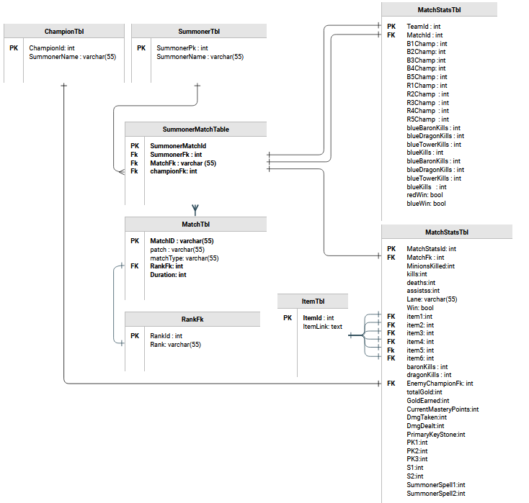

Figure E.1 Entity Relationship Diagram

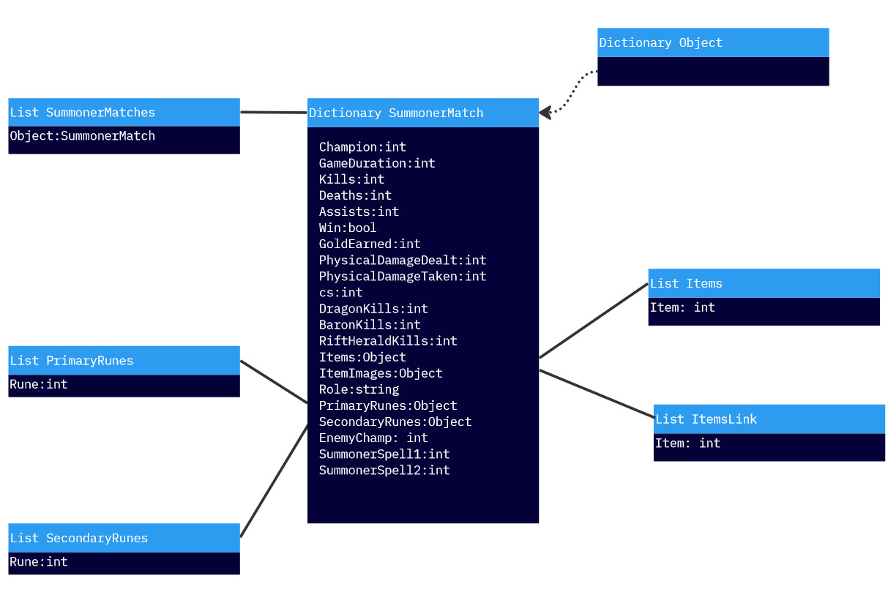

Figure E.2 UML Diagram for Matches Datastore

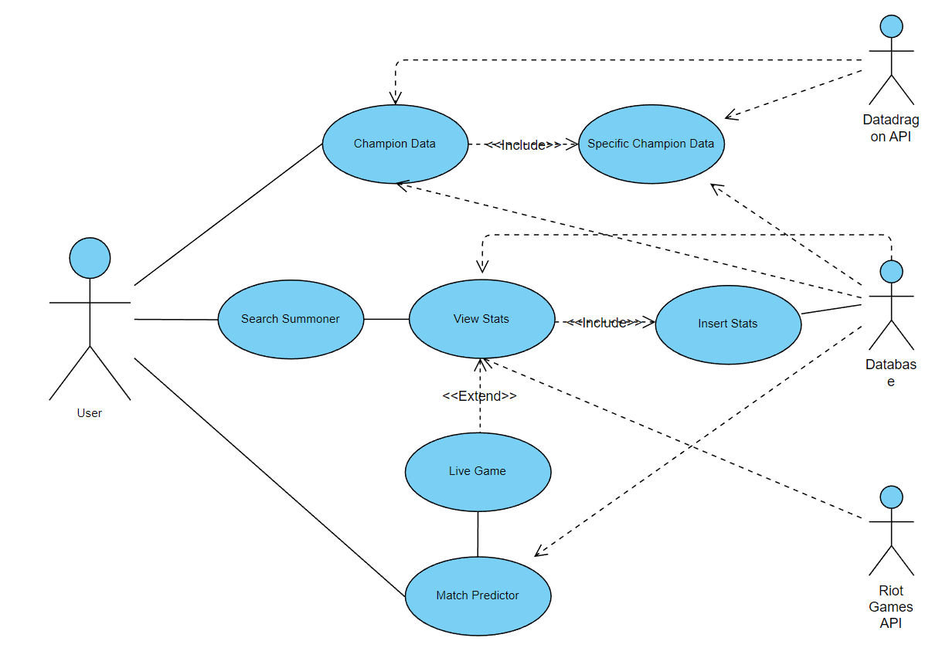

Figure E.3 Use Case Diagram

###### Design Report

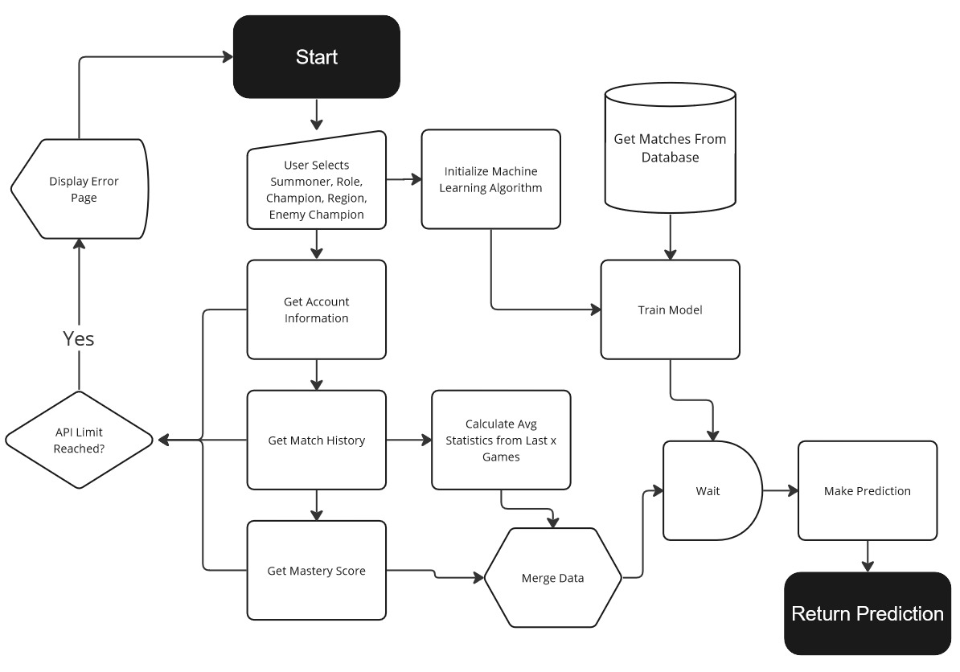

Figure F.1 Solo Predictor

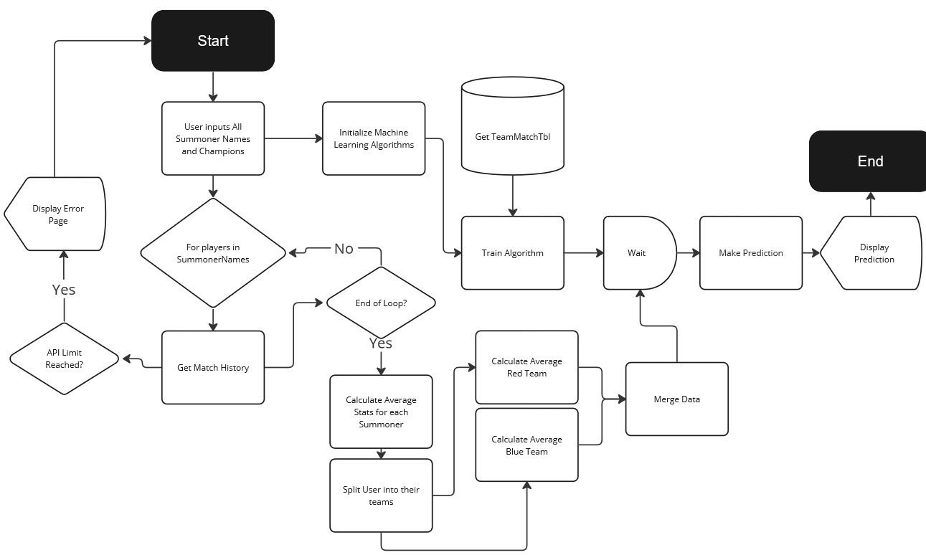

Figure F.2 Team Predictor

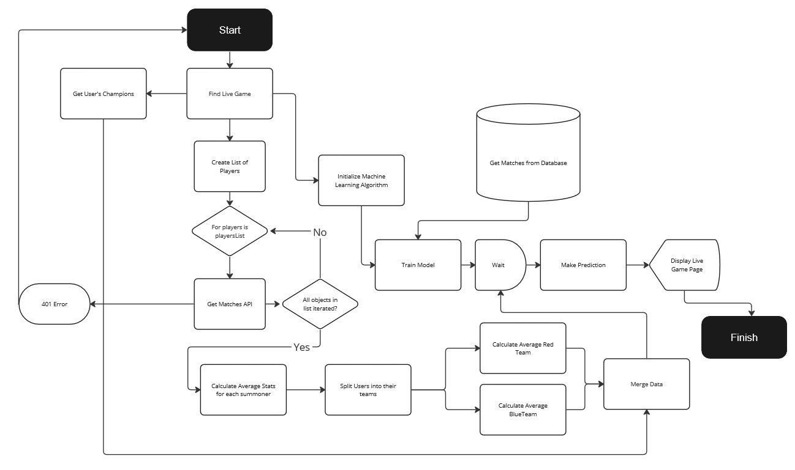 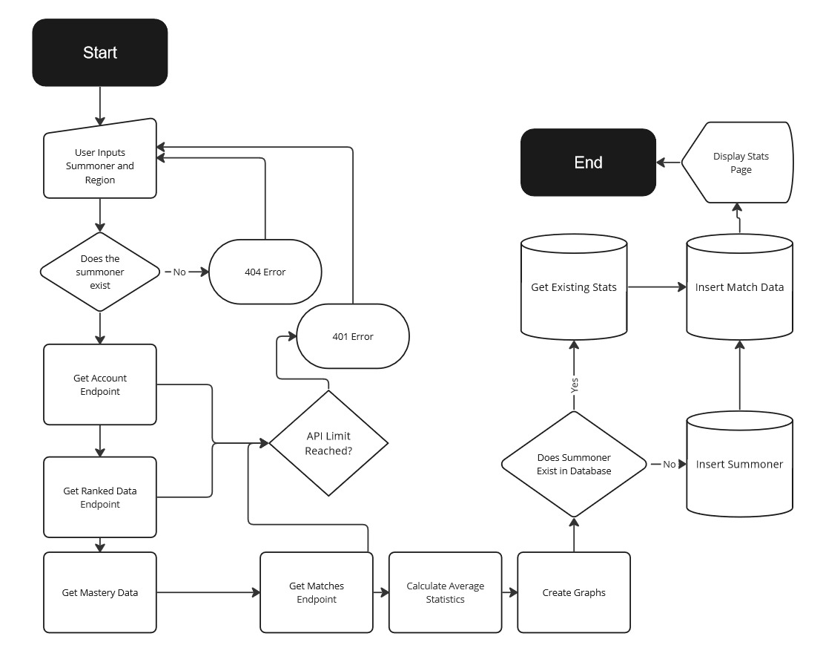

Figure . Live Game Predictor

Figure F.4 Query Summoner

|  |  |
| --- | --- |
| Data Feature | Description |
| Blue1Champ | The championId of the player blue side playing Top Lane. |
| Blue2Champ | The championId of the player blue side playing Jungle Lane. |
| Blue3Champ | The championId of the player blue side playing Middle Lane. |
| Blue4Champ | The championId of the player blue side playing Bottom Lane. |
| Blue5Champ | The championId of the player blue side playing Support Lane. |
| Red1Champ | The championId of the player red side playing Top Lane. |
| Red2Champ | The championId of the player red side playing Jungle Lane. |
| Red3Champ | The championId of the player red side playing Middle Lane. |
| Red4Champ | The championId of the player red side playing Bottom Lane. |
| Red5Champ | The championId of the player red side playing Support Lane. |
| BlueBaronKills | The average amount of baron taken by the blue team – calculated by the total of baron kills per game / games played for each player / team size. |
| BlueRiftHeraldKills | The average amount of rift heralds taken by the blue team – calculated by the total of rift herald kills per game / games played for each player / team size. |
| BlueDragonKills | The average amount of dragon kills taken by the blue team – calculated by the total of rift herald kills per game / games played for each player / team size. |
| BlueTowerKills | The average amount of tower kills by the blue team – calculated by the total of tower kills per game / games played for each player / team size. |
| BlueKills | The average amount of kills by the blue team – calculated by the total of kills per game / games played for each player / team size. |
| RedBaronKills | The average amount of baron taken by the red team – calculated by the total of baron kills per game / games played for each player / team size. |
| RedRiftHeraldKills | The average amount of rift heralds taken by the red team – calculated by the total of rift herald kills per game / games played for each player / team size. |
| RedDragonKills | The average amount of dragon kills taken by the red team – calculated by the total of rift herald kills per game / games played for each player / team size. |
| RedTowerKills | The average amount of tower kills by the red team – calculated by the total of tower kills per game / games played for each player / team size. |
| RedKills | The average amount of kills by the red team – calculated by the total of kills per game / games played for each player / team size. |
| RedWin | Result of the Match for the Red Team – 1 for win 0 for loss. |
| BlueWin | Result of the Match for the Blue Team – 1 for win 0 for loss. |

Table F.1 Data Points in the TeamMatchTable

|  |  |
| --- | --- |
| Data Feature | Description |
| MinionsKilled (cs) | The number of minions the player killed in-game |
| DmgDealt | The total amount of damage the player dealt within the game (all damage types included) |
| DmgTaken | The total amount of damage given within the game (all damage types included) |
| TurretKills | The number of turrets killed in-game. |
| TotalGold | The total amount of gold the player earnt during the match. |
| Lane | The role played in-game by the current summoner (top, jungle, middle,  bottom). |
| Win | If the player won the match, either result is 1 for a win or 0 for a loss |
| Item (1-6) | Each item slot is designated a value of the ItemID. |
| Kills | The number of times a user has killed an opposing player in game. |
| Deaths | The number of times a player has been killed in game. |
| assists | The number of times a player has contributed to the death of an opposing player. |
| PrimaryKeyStone | The primary keystone taken by the player, is stored by ID. |
| PrimarySlot (1-3) | The primary keystone slots taken by the player, stored by ID, stored separately. |
| SecondarySlot (1-2) | The secondary keystone slots taken by the player, stored by ID, stored separately. |
| EnemyChampion | ChampionId of the summoner playing the opposite role of the current laning summoner within the game (For Example j­­­­­ungle will have an enemy champ also in jungle). |
| SummonerSpell(1-2) | The summoner spells the user took in game, store by int, stored individually. |
| CurrentMasteryPoints | The amount of experience a user has on a given champion at recorded at the time of the stats being recorded. |
| DragonKills | The number of dragons taken by the team of the current summoner. |
| BaronKills | The number of Barons taken by the team of the current summoner. |
| Duration | Game length in milliseconds. |
| Champion | ChampionId of the champion selected by the summoner in the specific match. |

Table F.2 Data Points in MatchStatsTable

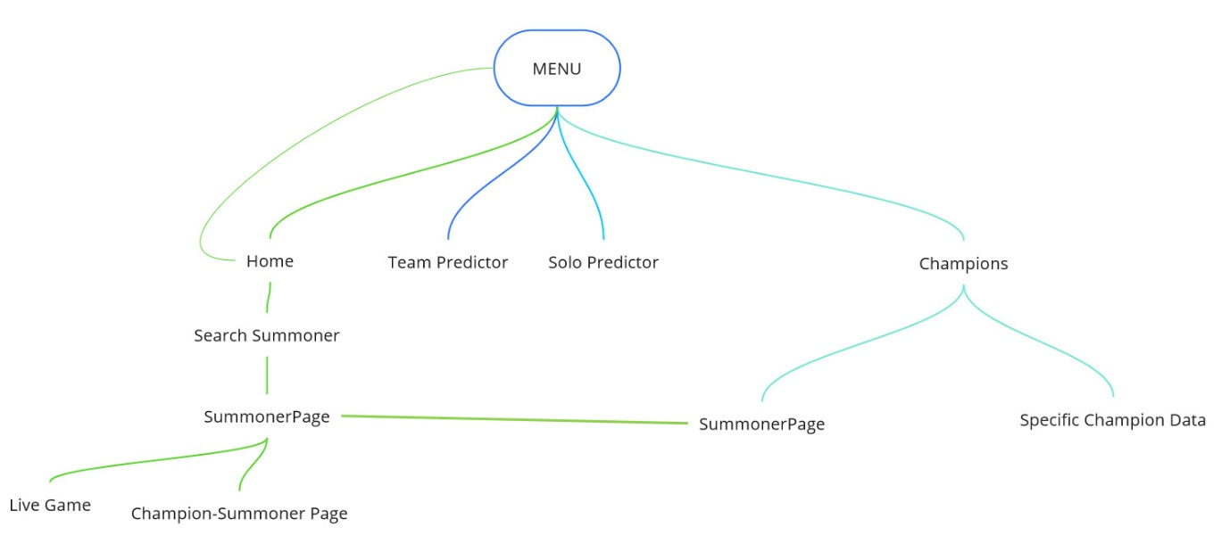

Figure F.5 Menu Structure

###### Implementation

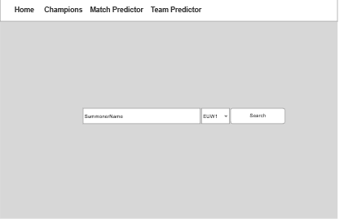

Figure G.1 Home Page Wireframes

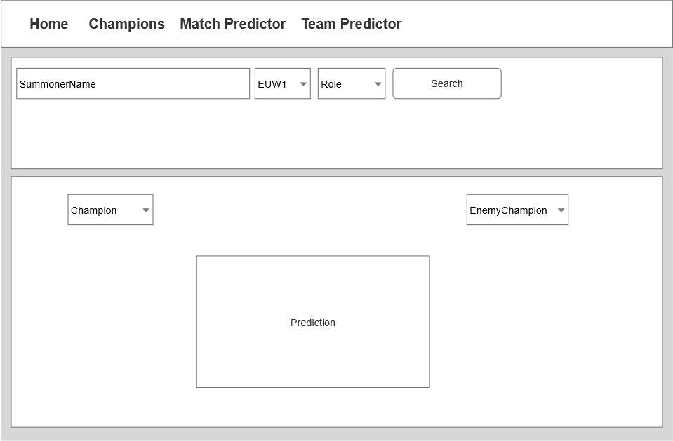

Figure G.2 Solo Predictor Wireframe

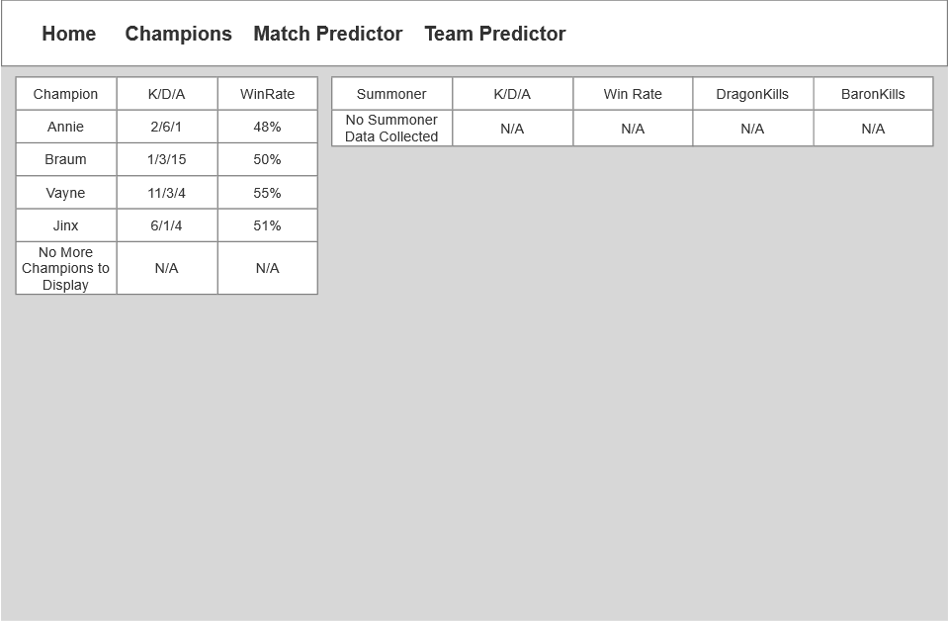

Figure G.3 Champions Page Wireframe

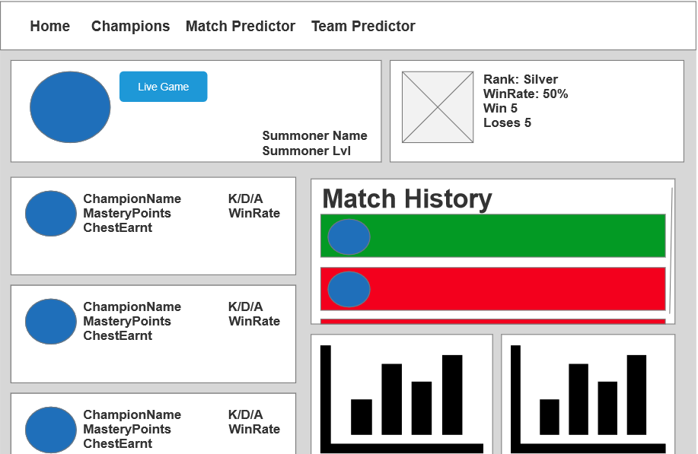

Figure G.4 Summoner Page Wireframe

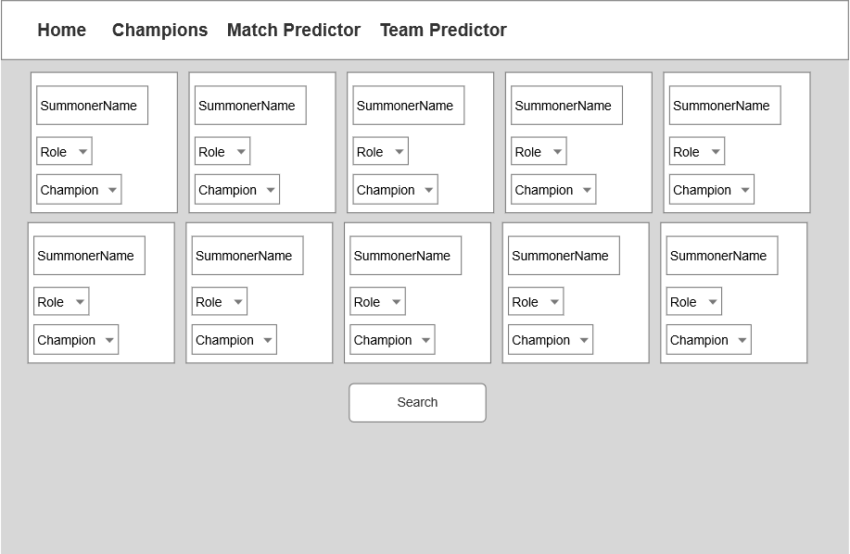

Figure G.5 Match Predictor Wireframe

|  |  |
| --- | --- |
| Code Written | Link |
| App.py | <https://github.com/NathanSmallcalder/Dissertation/blob/main/server/app.py> |
| Dockerfile | <https://github.com/NathanSmallcalder/Dissertation/blob/main/server/Dockerfile> |
| Makefile | <https://github.com/NathanSmallcalder/Dissertation/blob/main/server/Makefile> |
| RiotApiCalls.py | <https://github.com/NathanSmallcalder/Dissertation/blob/main/server/RiotApiCalls.py> |
| databaseQuries.py | <https://github.com/NathanSmallcalder/Dissertation/blob/main/server/databaseQuries.py> |
| championRequest.py | <https://github.com/NathanSmallcalder/Dissertation/blob/main/server/championsRequest.py> |
| DatabaseCollectionScripts | <https://github.com/NathanSmallcalder/Dissertation/blob/main/server/DatabaseCollectionScripts/Champion.py>  <https://github.com/NathanSmallcalder/Dissertation/blob/main/server/DatabaseCollectionScripts/DataCollection.py>  <https://github.com/NathanSmallcalder/Dissertation/blob/main/server/DatabaseCollectionScripts/teamDataCollection.py>  <https://github.com/NathanSmallcalder/Dissertation/blob/main/server/DatabaseCollectionScripts/ItemCollection.py> |
| HTML Pages | <https://github.com/NathanSmallcalder/Dissertation/blob/main/server/templates/500.html>  <https://github.com/NathanSmallcalder/Dissertation/blob/main/server/templates/base.html>  <https://github.com/NathanSmallcalder/Dissertation/blob/main/server/templates/championData.html>  <https://github.com/NathanSmallcalder/Dissertation/blob/main/server/templates/champions.html>  <https://github.com/NathanSmallcalder/Dissertation/blob/main/server/templates/index.html>  <https://github.com/NathanSmallcalder/Dissertation/blob/main/server/templates/matchPrediction.html>  <https://github.com/NathanSmallcalder/Dissertation/blob/main/server/templates/summonerChampion.html>  <https://github.com/NathanSmallcalder/Dissertation/blob/main/server/templates/summonerInGame.html>  <https://github.com/NathanSmallcalder/Dissertation/blob/main/server/templates/summonerPage.html>  <https://github.com/NathanSmallcalder/Dissertation/blob/main/server/templates/teamMatchPrediction.html> |
| Tests | <https://github.com/NathanSmallcalder/Dissertation/blob/main/server/tests/test_Champions.py>  <https://github.com/NathanSmallcalder/Dissertation/blob/main/server/tests/test_database.py>  <https://github.com/NathanSmallcalder/Dissertation/blob/main/server/tests/test_endpoint.py>  <https://github.com/NathanSmallcalder/Dissertation/blob/main/server/tests/test_machineLearning.py> |

Table G.1 Code Written

|  |  |  |  |
| --- | --- | --- | --- |
| Code Amended | Link | References |  |
| OpenTab Function | <https://github.com/NathanSmallcalder/Dissertation/blob/5a16fd9a3bb8dc3a623b33343bbc6127280a4ae0/server/templates/summonerPage.html#L62> | <https://codepen.io/t7team/pen/ZowdRN> |  |
| CSS Hover box | <https://github.com/NathanSmallcalder/Dissertation/blob/5a16fd9a3bb8dc3a623b33343bbc6127280a4ae0/server/templates/championData.html#L29> | <http://jsfiddle.net/UNs9J/1/> |  |

Table G.2 Code Amended

###### Testing

|  |  |  |  |  |
| --- | --- | --- | --- | --- |
| Test Case | Description | Test Step | Expected Results | Status |
| API – getChampImageSingle() | Gets Champion Image from a given champ Id. | Pass in random champ ids to receive an image URL. | Response code 200 | Pass |
| API – getChampDetails | Gets details of a given champion. | Pass in a champion and check to see if a JSON was received. | Response code 200 | Pass |
| API – getChampAbilities() | Gets champion abilities from Datadragon API. | Pass a champion and check to see if a JSON was received. | Response code 200 | Pass |
| API-getChampSpellImages() | Gets champion spell images from Datadragon API. | Pass a champion and check to see if a JSON was received. | Response code 200 | Pass |
| API- getChampImages() | Gets champion image for each champion in the mastery score array. | Pass the mastery score array into the method and request each link. | Response code 200 | Pass |
| API- getRunesImages() | Get rune images link for each rune by ID. | Pass rune array from database into method and request each link. | Response code 200 | Pass |
| API- getMasterySingle() | Gets a mastery score single value from the a given champion and mastery score array. | Pass a champion and mastery score into method. | Return a single value that matches the mastery score on client. | Pass |
| API – getSummoner() | Gets summoner details. | Retrieve summoner details from account endpoint. | Check if keys exist. | Pass |
| API – GetImageLink() | Gets the profile image icon from a profileId. | Pass an id into method and request the link. | Response code 200 | Pass |
| API- avgSummData() | Gets the averages for the last 5 matches of the summoner. | Retrieve match data, add it together and divide it by number of games. | Values should not be 0.  Values should match averages calculated separately. | Pass |
| API – getMatchData() | Gets match details. | Retrieve match details from account endpoint. | Check if keys exist. | Pass |
| API – Rank Images | Gets Ranked Icon Images | Pass in rank to method and send a get request to the link. | Pass | Pass |
| API – CalcWinRate | Calculates user win rate. | Pass in rank dictionary to method. | Value should be the value of win / total games * 100. | Pass |
| API – calculateAvgTeamStats | Calculates the average stats across a team | Pass players into a list and pass them into the method. | Check if keys exist. | Pass |
| API - getImageRoles | Get Role Images. | Pass a role into the method, then request the link returned. | Response code 200 | Pass |
| API – getRoles | Get Roles | Call the method and request links. | Response Code 200 | Pass |

Table H.1 API Testing

|  |  |  |  |  |
| --- | --- | --- | --- | --- |
| Test Case | Description | Test Step | Expected Results | Status |
| Database query  (Common Items) | Gets items with the highest number of occurences on a given champ | Run the query with random champion ID. | Pass | Pass |
| Database query  (Best Items) | Gets items with the highest number of wins on a given champ | Run the query with random champion ID. | Pass | Pass |
| Database Query  (Best Runes) | Gets the best runes on a given champ. | Run the query with random champ ID. | Pass | Pass |
| Database Query  (Common Runes) | Gets the most occurrences of runes on a given champ | Run the query with random champ ID. | Pass | Pass |
| Database Query  (Best Secondary Runes) | Gets the best runes on a given champ | Run the query with random champ ID. | Pass | Pass |
| Database Query  (Common Secondary Runes) | Gets the most common runes on a given champ. | Run the query with random champ ID. | Pass | Pass |
| Database Query  (laneFromDatabase | Test the method laneFromDatabase(champId) | Run the method with a champion that plays 1 lane. | Pass | Pass |
| Database Query (KdaFromDatabase) | Test the method kdaFromDatabaseSumm() | Run the method and check format of result “K/D/A” | Pass | Pass |
| Database Query (Avg Gold) | Test the method AvgGold () | Run the method with a champion in the database. Value Should not be 0. | Pass | Pass |
| Database Query (Avg Gold Summoner) | Test the method AvgGoldSummoner() | Run the method with a user in the database. Value Should not be 0. | Pass | Pass |
| Database Query (avgDmgDealt) | Test the method avgDmgDealt() | Run the method with a champion in the database. Value Should not be 0. | Pass | Pass |
| Database Query (avgDmgDealtSummoner) | Test the method avgDmgDealtSummoner() | Run the method with a user in the database. Value Should not be 0. | Pass | Pass |
| Database Query (avgDmgTaken) | Test the method avgDmgTaken() | Run the method with a champion in the database. Value Should not be 0. | Pass | Pass |
| Database Query (avgDmgTakenSummoner) | Test the method avgDmgTakenSummoner() | Run the method with a user in the database. Value Should not be 0. | Pass | Pass |
| Database Query (avgMinions) | Test the method avgMinions() | Run the method with a champion in the database. Value Should not be 0. | Pass | Pass |
| Database Query (avgMinionsSummoner) | Test the method  avgMinionsSummoner() | Run the method with a user in the database. Value Should not be 0. | Pass | Pass |
| Database Query (champKills) | Test the method champKills() | Run the method with a champion in the database. Value Should not be 0. | Pass | Pass |
| Database Query (champWins) | Test the method champWins() | Run the method with a champion in the database. Value Should not be 0. | Pass | Pass |
| Database Query (totalGames) | Test the method totalGames() | Run the method with a champion in the database. Value Should not be 0. | Pass | Pass |
| Database Query (totalGamesOnSummoner) | Test the method totalGamesOnSummoner() | Run the method with a user in the database. Value Should not be 0. | Pass | Pass |
| Database Query (champWinsSummoner) | Test the method champWinsSummoner() | Run the method with a user in the database. Value Should not be 0. | Pass | Pass |
| Database Query (laneFromDatabaseSummoner) | Test the method laneFromDatabaseSummoner() | Run the method with a user in the database. Value Should not be 0. | Pass | Pass |
| Database Query (getItemLink) | Test the Query getItemLink() | Run the method with a champion in the database. Value Should not be 0. | Pass | Pass |
| Database Query (getAllChampions) | Test the method getAllChampions() | Run the method. Length should be over 130. | Pass | Pass |
| Database Query (getBestPlayers) | Test the method getBestPlayers() | Run the method. Array length should be greater than 5. | Pass | Pass |
| Database Query (getChampionAverages) | Test the method getChampionAverages() | Run the method. Length should be over 130. | Pass | Pass |
| Database Query (getChampionBestPlayers) | Test the method getChampionBestPlayers() | Run the method. Array length should be greater than 5. | Pass | Pass |
| Database Query (avgMinionsAll) | Test the method avgMinionsAll () | Run the method with a champion in the database. Value Should not be 0. | Pass | Pass |

Table H.2 Database Query Testing

|  |  |  |  |
| --- | --- | --- | --- |
| Test | Test Step | Image | Score |
| Match Predictor | Host the site.  Copy URL into siteimprove.com. |  | 97/100 |
| Champions Page | Host the site.  Copy URL into siteimprove.com. |  | 98/100 |
| Team Predictor Page | Host the site.  Copy URL into siteimprove.com. |  | 96/100 |
| Summoner-champion  page | Host the site.  Copy URL into siteimprove.com. |  | 86/100 |

Table H.3 Accessibility Testing

|  |  |  |  |  |
| --- | --- | --- | --- | --- |
| Test Case | Description | Test Step | Expected Results | Status |
| Endpoint  Champions Page | Test the champions endpoint by sending a get request to the address. | Server Must be Running.  Request <http://localhost:5000/champions> | Status code 200 | Pass |
| Specific Champion Page | Test the Specific champion page by sending a get request to the address. | Server Must be Running.  Request <http://localhost:5000/champions?champion=Annie> | Status code 200 | Pass |
| Summoner Page | Test the Summoner page by sending a get request to the address. | Server Must be Running.  Request <http://localhost:5000/summoner?summoner=Mealsz&region=EUW1> | Status code 200 | Pass |
| Champion SummonerPage | Test the Specific summoner/champion page by sending a get request to the address. | Server Must be Running.  Request <http://localhost:5000/summoner/champion?summoner=Mealsz&region=EUW1&champion=Annie> | Status code 200 | Pass |
| Index Page | Test the Specific champion page by sending a request to the address. | Server Must be Running.  Request <http://localhost:5000/> | Status code 200 | Pass |
| Solo Prediction Endpoint | Test the Specific champion page by sending a post request to the address. | Server Must be Running.  Post <http://localhost:5000/preidctSolo>  {  "MinionsKilled": 258,  "kills": 25,  "assists": 56,  "deaths": 1,  "TotalGold": 32355,  "DmgDealt": 422425,  "DmgTaken": 24567,  "DragonKills": 4,  "BaronKills": 3,  "GameDuration": 200,  "TurretDmgDealt": 4,  "ChampionFk": 1,  "masteryPoints": 42257,  "EnemyChampionFk":2 ,  "lane": 1  } | Status code 200  and  Json Response = 0 or 1 | Pass |
| Team  Prediction Endpoint | Test the Specific champion page by sending a post request to the address. | Server Must be Running.  Post <http://localhost:5000/teamData>  {  "B1Summ": "Mealsz",  "B2Summ": "Ehhhh",  "B3Summ": "Itwoznotmee",  "B4Summ": "Lil Nachty",  "B5Summ": "Forza Napøli ",  "R1Summ": "Primabel Ayuso",  "R2Summ": "NateNatilla",  "R3Summ": "sweet af",  "R4Summ": "Fedy9 ",  "R5Summ": "ChampagneCharlie ",  "B1": 44,  "B2": 876,  "B3": 136,  "B4": 221,  "B5": 74,  "R1": 122,  "R2": 20,  "R3": 99,  "R4": 202,  "R5": 412,  'Region':"EUW1"  } | Status code 200  and  Json Response = 0 or 1 | Pass |

Table H.4 Endpoint Testing Table

|  |  |  |  |  |
| --- | --- | --- | --- | --- |
| Test Case | Description | Test Step | Expected Results | Status |
| Team Predictor Obvious Loss | Pass in a scenario where the red team should lose the match. | "B1": 44,  "B2": 876,  "B3": 136,  "B4": 221,  "B5": 74,  "R1": 122,  "R2": 20,  "R3": 99,  "R4": 202,  "R5": 412,  "BlueBaronKills":1, "BlueRiftHeraldKills":2,  "BlueDragonKills":2.33,  "BlueTowerKills": 9,  "BlueKills": 37,  "RedBaronKills":0.3333,  "RedRiftHeraldKills": 0,  "RedDragonKills": 0,  "RedTowerKills": 0,  "RedKills":0, | Red Team Should lose the match. | Pass |
| Team Predictor Less Obvious Loss | Pass in a scenario where the red team should lose the match. | "B1": 44,  "B2": 876,  "B3": 136,  "B4": 221,  "B5": 74,  "R1": 122,  "R2": 20,  "R3": 99,  "R4": 202,  "R5": 412,  "BlueBaronKills": 1,  "BlueRiftHeraldKills":2,  "BlueDragonKills": 2.33,  "BlueTowerKills": 9,  "BlueKills": 37,  "RedBaronKills": 0.3333,  "RedRiftHeraldKills": 0.2,  "RedDragonKills": 0,  "RedTowerKills": 2,  “RedKills": 15, | Red Team should lose the match. | Pass |
| Team Predictor Less Obvious Loss | Pass in a scenario where the red team should lose the match. | "B1": 44,  "B2": 876,  "B3": 136,  "B4": 221,  "B5": 74,  "R1": 122,  "R2": 20,  "R3": 99,  "R4": 202,  "R5": 412,  "BlueBaronKills": 1,  "BlueRiftHeraldKills":2,  "BlueDragonKills": 2.33,  "BlueTowerKills": 9,  "BlueKills": 37,  "RedBaronKills": 1,  "RedRiftHeraldKills": 2.2,  "RedDragonKills": 2,  "RedTowerKills": 4,  “RedKills": 26, | Red Team should lose the match. | Pass |
| Team Predictor Red Win | Pass in a scenario where red team win the match. | "B1": 44,  "B2": 876,  "B3": 136,  "B4": 221,  "B5": 74,  "R1": 122,  "R2": 20,  "R3": 99,  "R4": 202,  "R5": 412,  "BlueBaronKills": 1,  "BlueRiftHeraldKills":1,  "BlueDragonKills": 2.33,  "BlueTowerKills": 5,  "BlueKills": 23,  "RedBaronKills": 3.2,  "RedRiftHeraldKills": 2,  "RedDragonKills": 3.33,  "RedTowerKills": 7,  “RedKills": 46, | Red Team Should win the match. | Pass |
| Solo Predictor  ObviousLoss | Pass in a scenario where the user loses the match. | Champion: 1,  MinionsKilled:0,  Kills:0,  Deaths:50,  Assists:2,  Lane:1,  masteryPoints:200,  DmgDealt: 200,  DmgTaken: 5000,  TurretDmg: 0,  TotalGold: 2000,  EneemyChampion: 5,  GameDuration: 1220, DragonKills: 0,  BaronKills: 0 | User should lose the match. | Pass |
| Solo Predictor Most Likely Loss | Pass in a scenario where the user is most likely to lose. | Champion: 1,  MinionsKilled:100,  Kills:1,  Deaths:10,  Assists:5,  Lane:2,  masteryPoints:250,  DmgDealt: 5000,  DmgTaken: 10000,  TurretDmg: 2,  TotalGold: 2500,  EneemyChampion: 5,  GameDuration: 2500, DragonKills: 0,  Baron Kills: 0 | User loses the game | Pass |
| Solo Predictor  Most Likely Win | Pass in a scenario where the user is most likely to win | Champion: 1,  MinionsKilled:100,  Kills:20,  Deaths:3,  Assists:5,  Lane:2,  masteryPoints:4000,  DmgDealt: 6000,  DmgTaken: 4399,  TurretDmg: 2,  TotalGold: 2500,  EnemyChampion: 5,  GameDuration: 2500, DragonKills: 2,  BaronKills: 1 | User should win the match | Pass |
| Solo Predictor  Certain Win | Pass in a scenario where the user should win the match. | Champion: 1,  MinionsKilled:259,  Kills:25,  Deaths:1,  Assists:25,  Lane:5,  masteryPoints:40000,  DmgDealt: 30000,  DmgTaken: 4399,  TurretDmg: 5,  TotalGold: 5999,  EnemyChampion: 5,  GameDuration: 3000, DragonKills: 4,  BaronKills: 2 | User should win the match. | Pass |

Table H.5 Machine Learning Testing

###### User Guide ­

To gain access to the application, navigate to <https://leaguetracker.ngrok.app/>. If the application is not running, you can download the git repository <https://github.com/NathanSmallcalder/Dissertation>. And add a file called config.py populated with the lines of code shown in Figure I.1 to the server directory.

api_key = "RGAPI-546ff69b-0cba-44ac-b79d-be1472f09bc1"

sql_password = "#uSltL*ZlXC%"

sql_user = 'o1gbu42_StatTracker'

host = '109.73.175.66'

Figure . Config.py Code

then run the application using:

cd server.

make build.

make run.

And navigate to <http://127.0.0.1:8001/>.

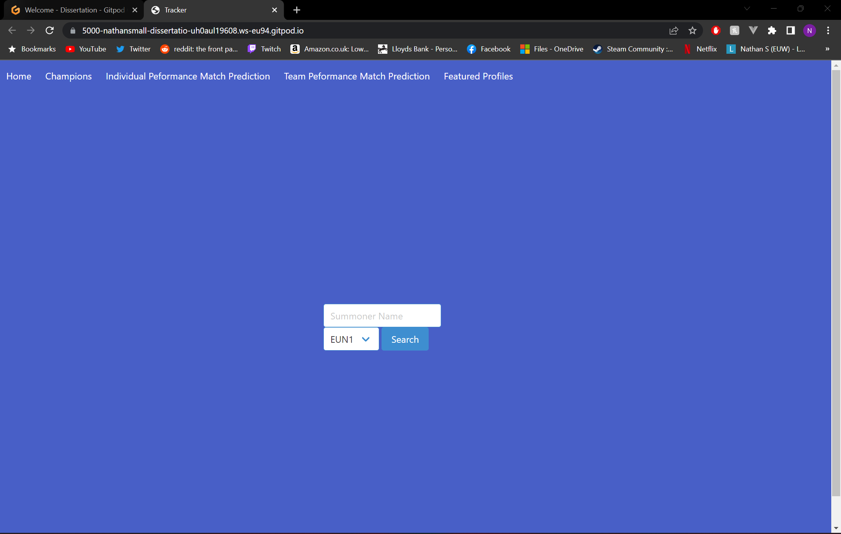

Figure I.2 Home Page

Figure I.2 shows the main page for the application, from here you can insert a summoner name (The users name in league of legends), region (The region of the summoner’s account) and search for the summoners account, which will take you to the Summoner Page of the summoner inserted. If the user does not have an existing league account, example accounts can be found within the GitHub README.

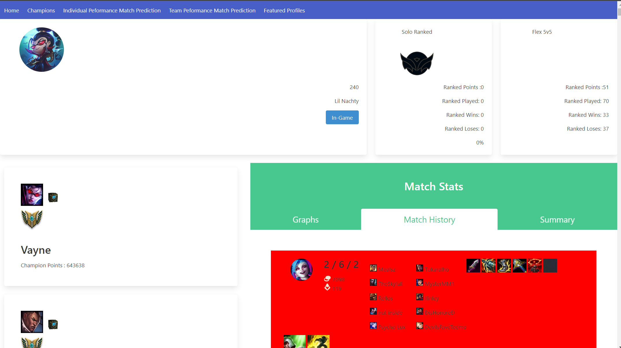

Figure I.3 Summoner Page

Figure I.3 shows the Summoner Page, from here the user can see graphs of their statistics from the database, matches they have played in, mastery score, and ranked information. From this page the user can view live games, which shows any live game that the user is playing in. The user can also click on a champion on the left of the page to see in-depth data on a specific champion that they have played on. If the user has not played on the champion they selected, they will be taken to an error page.

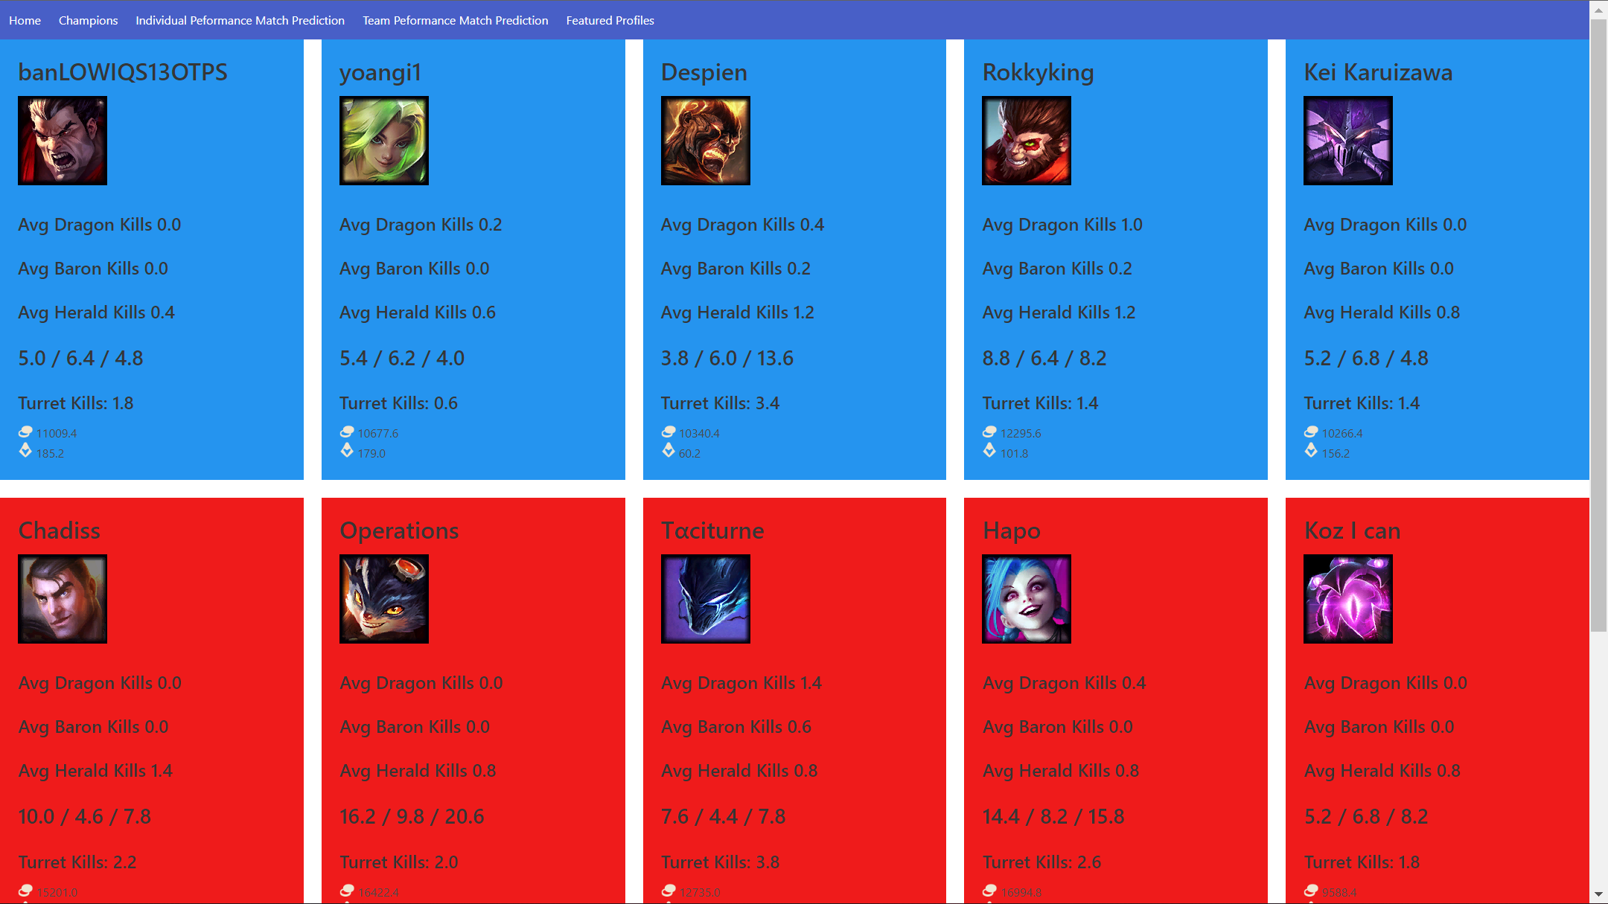

Figure I.4 Match Predictor

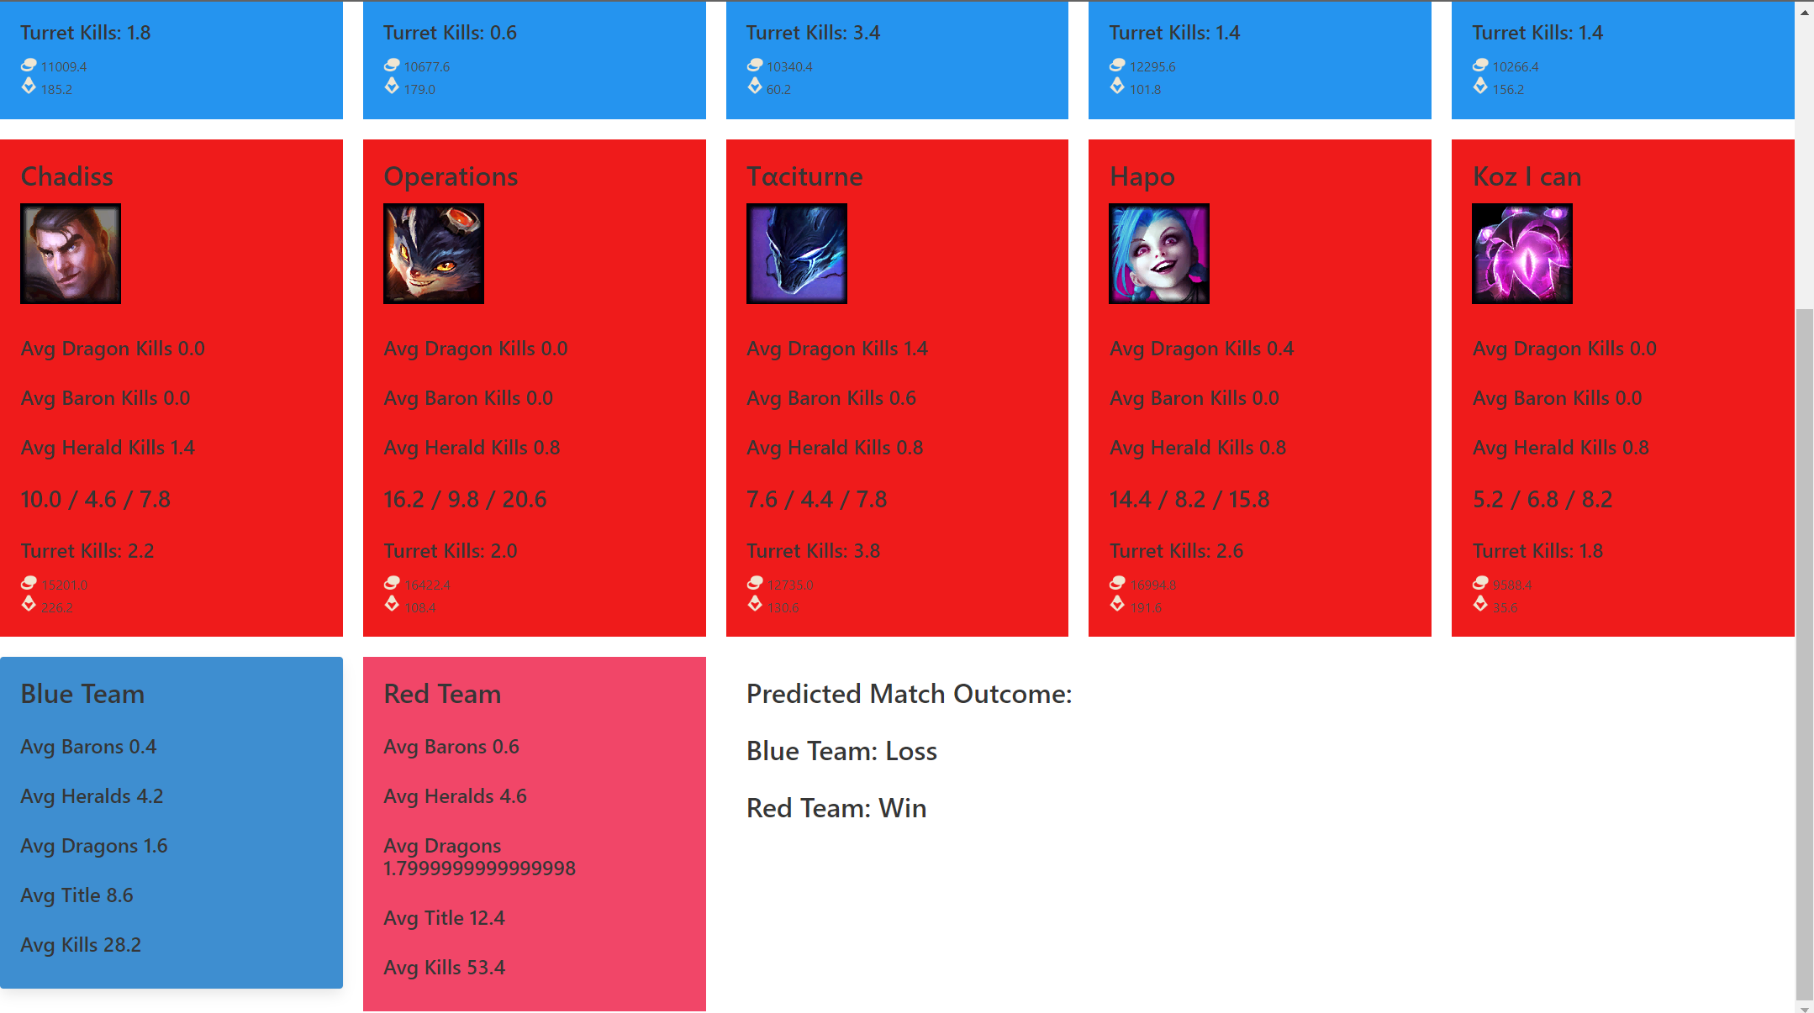

Figure I.5 Match Predictor Result

From the summoner page, the user can click on the live game tab, if the user is in a game, it will gather all the users in games stats, predict the match result and load the user interface shown in figure I.4 and figure I.5. If the user is not a game, the error page will show, and the user can navigate to the previous page.

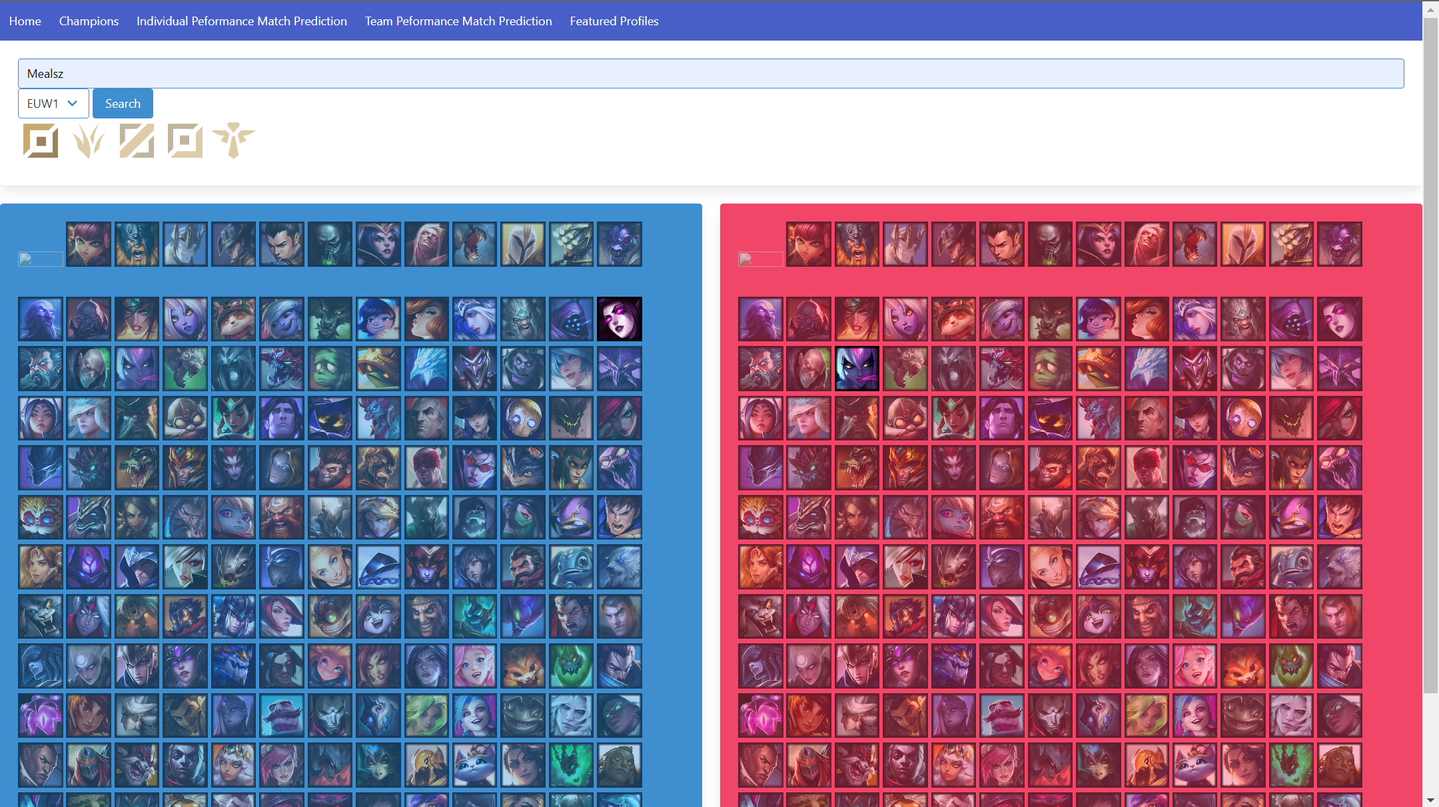

Figure I.6 Solo Predictor

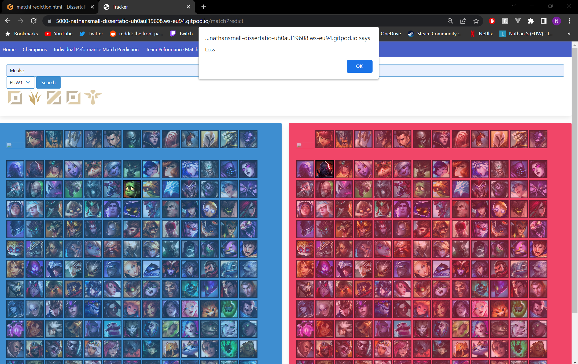

Figure I.7 Solo Predictor Result

Figure I.6 shows the solo predictor, on this page the user can input a name, region, role, champion, and enemy champion and click the search button to simulate a one-versus-one scenario. Users can select champions and roles by clicking on the images. After waiting, users are prompted with an alert, seen in figure I.7.

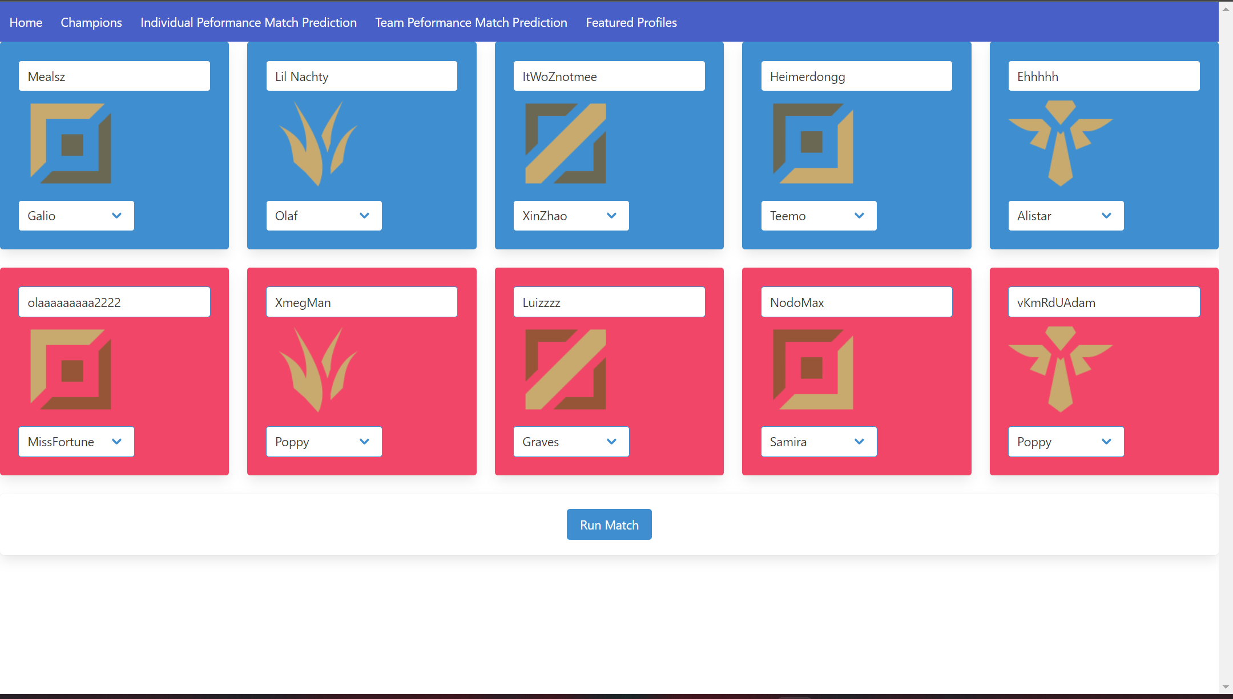

Figure I.8 Team Predictor

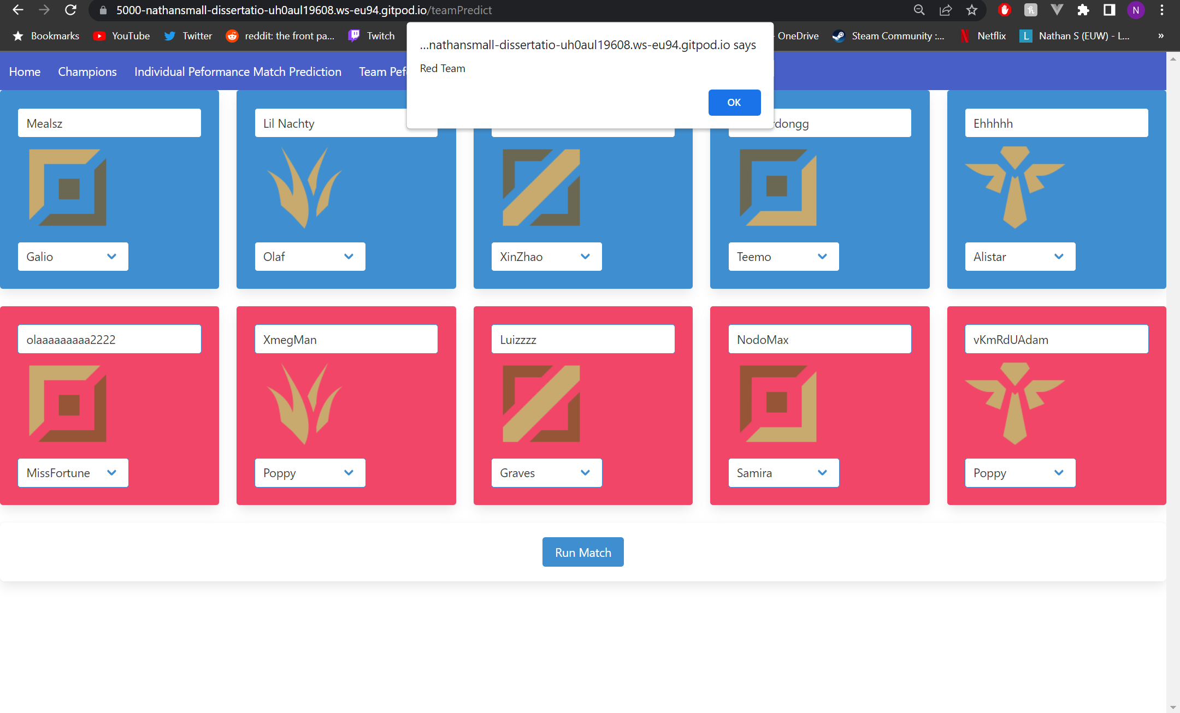

Figure I.9 Team Predictor Result

Figure I.8 shows the team predictor, users input ten players, five blue side players and five red side players into the specific role and side that corresponds to the role image and side colour. Users can select a champion for each player user the drop-down menu. After entering both sides information, the user can click the run match button to simulate the match. Upon waiting, the user should be prompted with an alert that either states blue side or red side as the match winner, seen in Figure I.9.

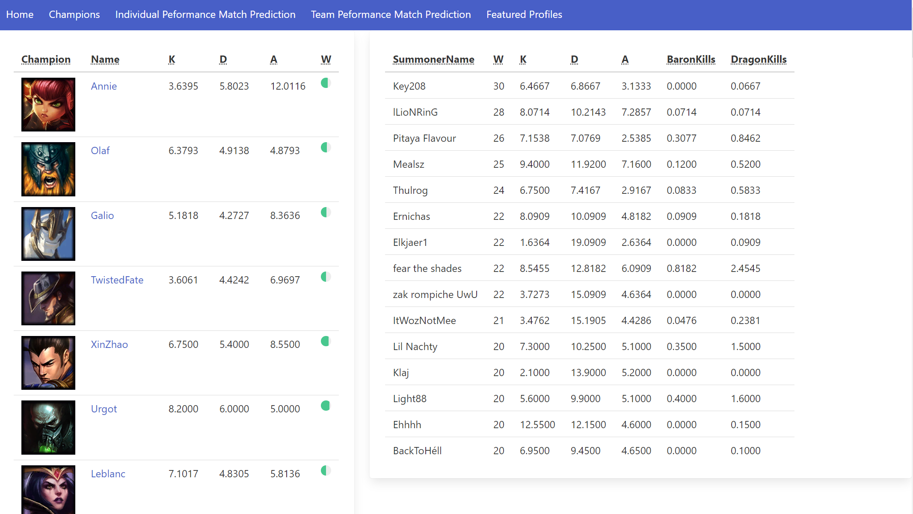

Figure I.10 Champions Page

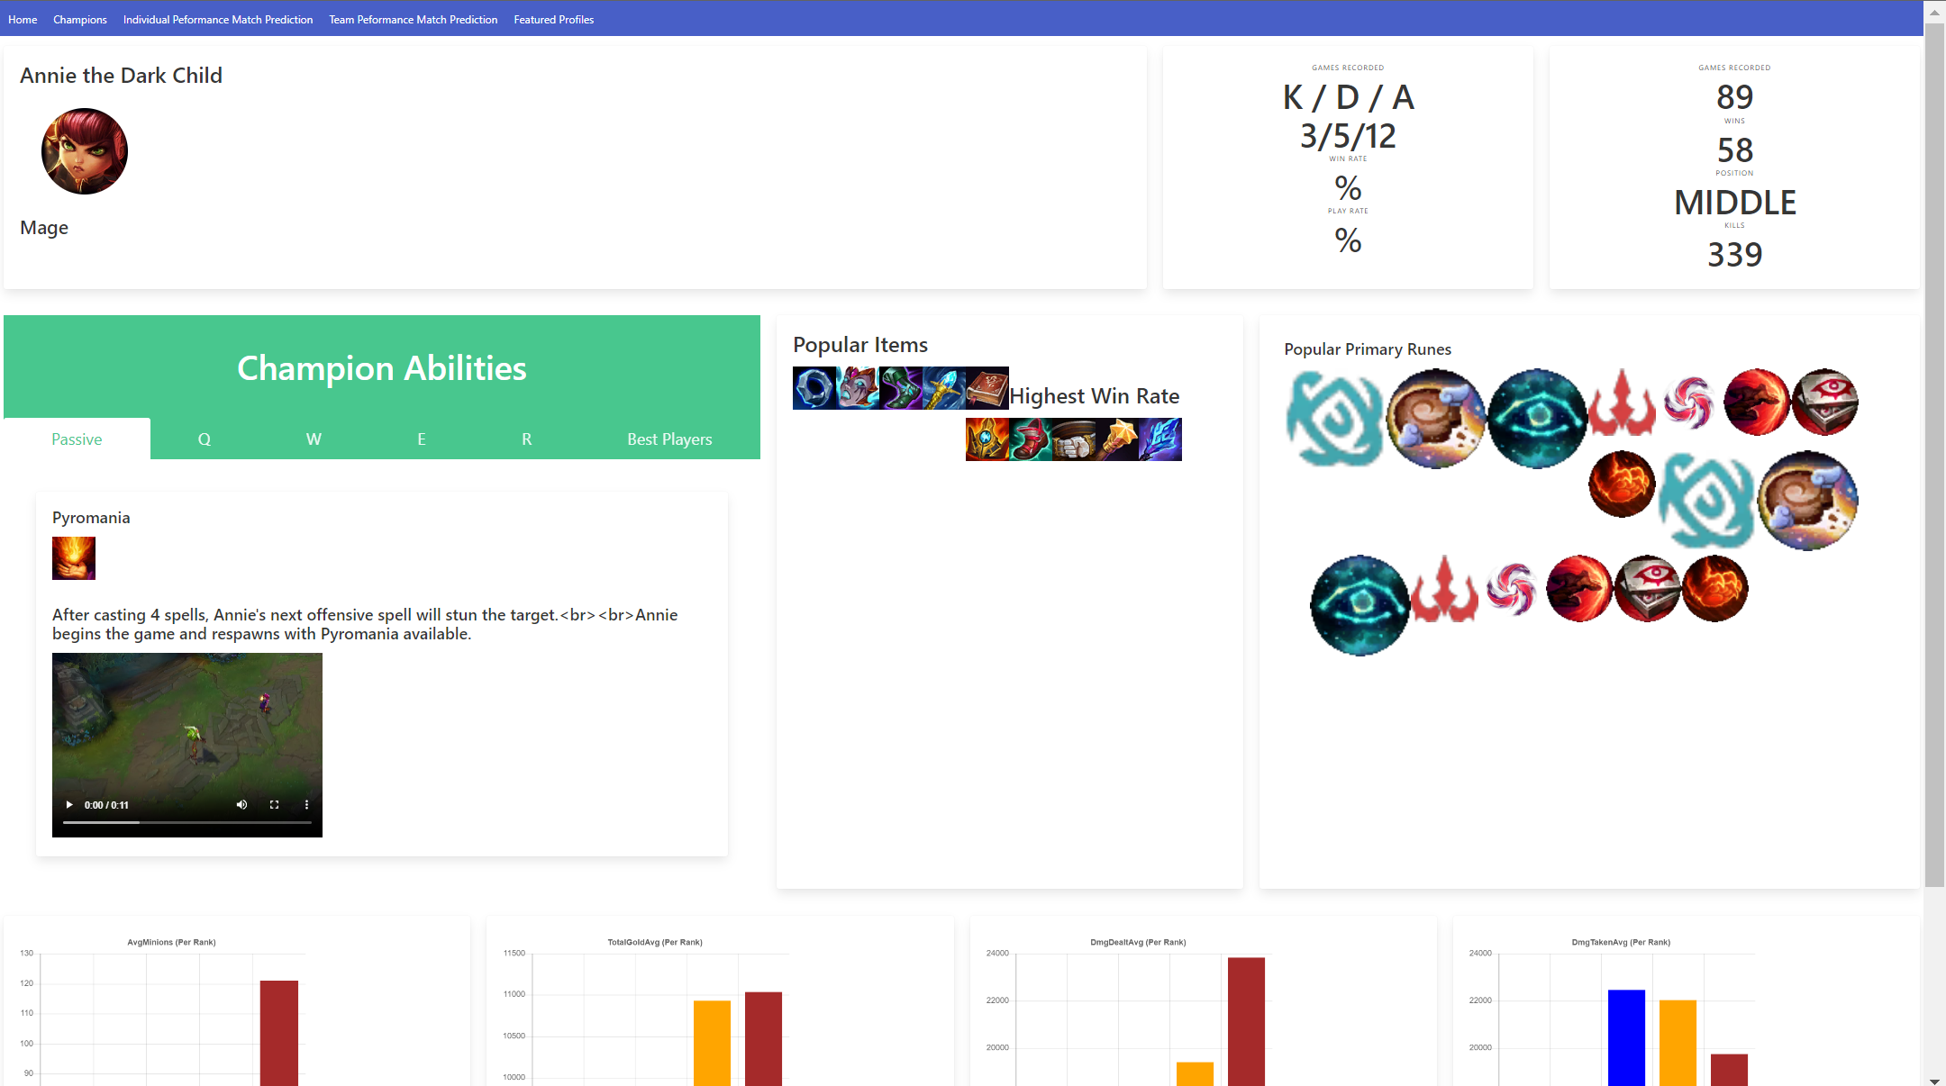

Figure I.11 Specific Champion Page

Figure I.10 shows the champion page, from here the user can see the best champions and summoners statistics in a table, sorted by wins. The user can click on a champion to get to the specific summary page, seen in figure I.11. This page shows the best runes, items, and summary data on the specific champion.

###### Project Management

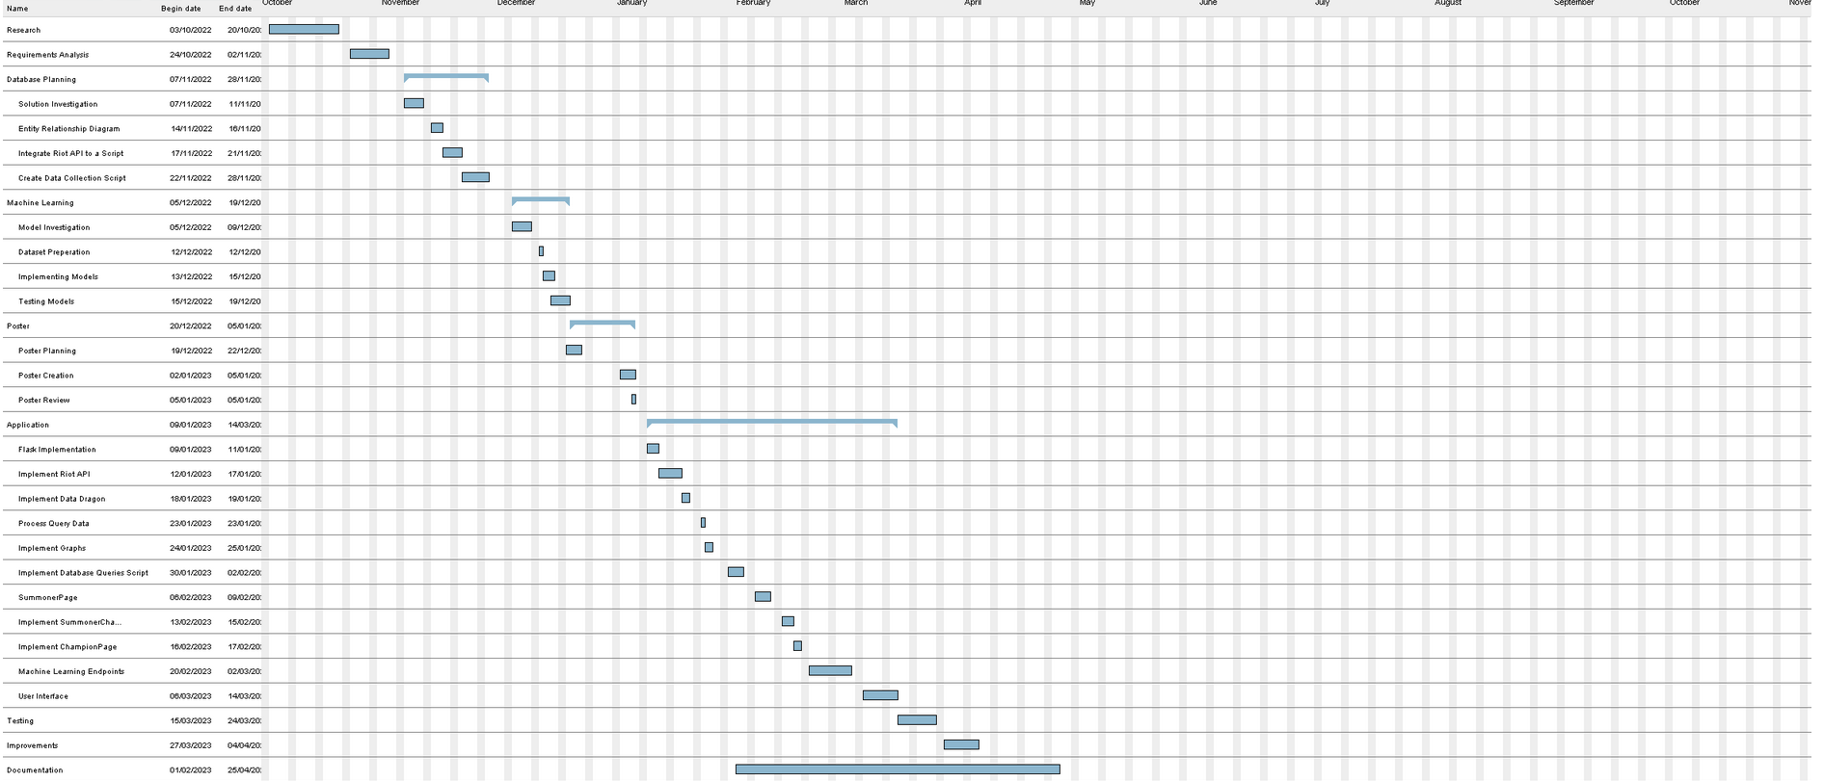

Figure J.1 Gantt Chart­

|  |  |  |
| --- | --- | --- |
| Task | Finish Date | Actions Required |
| Research | 19/10/2022 | N/A |
| Requirements Analysis | 02/11/2022 | N/A |
| Database Planning (Solution Investigation) | 12/11/2022 | N/A |
| Database Planning (ERD Diagram) | 17/11/2022 | Start API Testing Scripts on the 18/11/2022. |
| Riot API calls script | 22/11/2022 | Begin Data Collection script on the same day. |
| Database Planning (Data Collection) | 28/11/2022 | N/A |
| Issue – Database Storage (Normalised data, added fields). | 05/12/2022 | Begin machine learning testing later |
| Machine Learning (Model Investigation) | 07/12/22 | Start Dataset preparation earlier. |
| Dataset Preparation/Further Collection | 09/12/22 | More time to implement models. |
| Machine Learning (Implement Models) | 15/12/22 | N/A |
| Testing Models | 19/12/22 | N/A |
| Poster (Planning) | 22/12/22 | N/A |
| Poster (Creation) | 02/01/22 | N/A |
| Poster Review | 05/01/22 | N/A |
| Application (Flask Implementation) | 11/01/22 | N/A |
| Application (Implement Riot API to endpoints) | 14/01/22 | Start DataDragon implementation sooner. |
| Application (Implement DataDragon) | 18/01/22 | N/A |
| Application (Process API Data) | 24/01/22 | N/A |
| Application (SummonerPage) | 31/01/22 | Specific match data not implemented. |
| Application (Implement Graphs) | 07/02/22 | Did not get time to implement advanced graphics. |
| Application (Implement Database Queries) | 10/02/22 | N/A |
| Implement Summoner Champion Page | 15/02/22 | N/A |
| Implement Champion Page | 20/02/22 | N/A |
| Implement Machine Learning Endpoints | 10/03/22 | Spend less time working on user interface to meet deadline. |
| User Interface | 14/03/22 | User interface looks underdeveloped in specific champion page. |
| Testing | 24/03/22 | N/A |
| Improvements | 28/03/22 | Ended improvements early to work on documentation |

Table J.1 Diversions in Development

|  |  |  |
| --- | --- | --- |
| Type | Requirement | Status |
| Functional | Integration with the Riot API | Completed |
| Functional | Integration with community dragon API | Completed |
| Functional | Query Players | Completed |
| Functional | Stat Tracking | Completed |
| Functional | User interface | Completed |
| Functional | Solo Match Prediction | Completed |
| Functional | Team Match Predictor | Completed |
| Functional | Live Game Prediction | Completed |
| Functional | Leaderboards | Completed |
| Functional | Champion leaderboards | Completed |
| Functional | Past games | Completed |
| Functional | Match history analysis | Completed |
| Functional | Item recommendations: | Completed |
| Functional | Build recommendations | Completed |
| Functional | Live game updates: | Completed |
| Functional | Champion Statistics | Completed |
| Functional | Champion Abilities | Completed |
| Functional | Champion Infographics | Completed |
| Functional | User Infographics | Completed |
| Functional | User-Champion Stats | Completed |
| Functional | User-Champion Infographics | Completed |
| Functional | Mastery Statistics | Completed |
| Functional | In-depth match statistics | Incomplete |
| Functional | Player Comparison | Incomplete |
| Non-Functional | Latest Stats | Completed |
| Non-Functional | Clear Infographics | Completed |
| Non-Functional | Accessibility | Completed |
| Non-Functional | Accuracy | Completed |
| Non-Functional | Usability | Completed |
| Non-Functional | Performance | Completed |
| Non-Functional | Compatibility | Completed |
| Non-Functional | Database Capacity | Completed |
| Non-Functional | User Capacity | Incomplete |
| Non-Functional | Maintainability | Completed |
| Non-Functional | Availability | Completed |
| Non-Functional | Localization | Incomplete |
| Non-Functional | Responsiveness | Completed |
| Non-Functional | Scalability | Completed |
| Non-Functional | Deploy ability | Completed |
| Non-Functional | Fault Tolerance | Completed |
| Non-Functional | Reliability | Completed |
| Non-Functional | User Interface Responsiveness | Completed |

Table J.2 Requirement Review

###### Meetings with Supervisor

|  |  |  |  |  |
| --- | --- | --- | --- | --- |
| Date | Location | Purpose | Description | Actions |
| 13/10/22 | Teams | Potential Ideas | Discussed Possibility Ideas:   * Analytical tool in Football. * Match Prediction tool in Football | Research Studies, Potential APIs, ML models. |
| 21/20/22 | Verena Holmes | Changes to Idea | Changed the topic of league of legends due to availability of statistics. Discussed tools/implementation strategy. | Plan program structure. |
| 11/10/22 | Verena Holmes | Project timeline | Set targets for the application/general workload to be completed by. | Create Gantt Chart. |
| 9/12/22 | Teams | Poster/Review of Diagrams | Discussed potential poster layout/review of the erd. | Begin Poster design and improvements to erd. |
| 5/01/23 | Teams | Poster Review/Progress Check | Discussed final improvements to poster and review of progress. | Implementing User interface for machine learning prediction. |
| 8/02/23 | Verena Holmes | Progress Check | Set deadlines for application, program improvements. | Programming to be finished before April 2023. |
| 07/03/23 | Teams | Progress Check Application | Program improvements/suggestions. | Match Simulation Feature |
| 27/03/23 | Teams | Progress Check Documentation | Review of Documentation | Improve wording, layout of document. |
| 26/04/23 | Verena Holmes | Progress Check Documentation | Review of Documentation | Improve document flow/program review. |

Table K‑1 - Meetings with Supervisor

###### Agile Development: Timebox 1

Not Applicable

###### Agile Development: Timebox 2

Not Applicable

###### Agile Development: Timebox 3

Not Applicable

###### Game Description

LoL is a competitive or casual team-based game, played in teams of 5, each team can select 1 of 162 champions, with the goal of destroying the others team’s nexus. The goals of both teams are to gather gold and destroy enemy turrets to reach the nexus, players can kill minions (CS), or enemy players to earn gold within the game, or passively earn gold over time. - gold can be used to buy items within the game to make the champion deal more damage, gain HP or offer unique abilities. Typically, each team consists of different champions with unique roles, tank, mage, bruiser, marksman and support. Players are assigned roles by choosing a role in the pre-game selection when entering a game players take turns to choosing and banning champions, as well as customizing their loadout by select runes and spells for the game.

During the first phase of the game, players must earn experience points (XP) to level up and unlock and upgrade abilities, XP is earnt by killing minions, jungle camps or killing enemy players, all champions begin at level 1 and can reach level 18 in each game. Later in the game, players can fight for objectives like the Baron – giving minions and players boosted stats for a small duration of time, or dragons – which provide permanent stat boost to all players on the team which claim the objective.

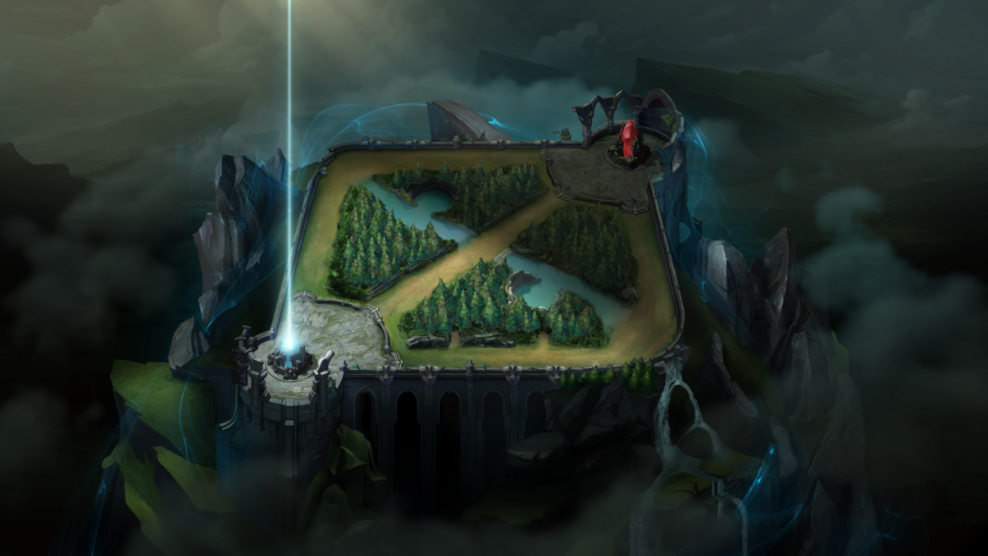

Figure . Summoners Rift Map

The game’s ranked setting takes place in Summoner’s Rift as seen in Figure 2, the map is split into 3 lanes, top, mid, and bottom. Both teams start in their base, in opposite corners of the map, with each player assigned to one lane of the map, and one player playing the jungle role, with 2 players playing the bottom lane. When creating a game, LoL enforces a matchmaking algorithm based on hidden elo rating, this system was designed to create matches for players at similar skill levels to keep the game balanced, the algorithm has undergone constant changes to identify the level of players to ensure players are participating in games at their skill level (Tiffany Do et al, 2021).

LoL is a constantly evolving and complex game, with the in-game “meta” changing constantly as champions and items receive new patches – the game changes vastly (Phillip, Z, Maymin,2021) and players must adapt quickly; a tool which provides players with data on the latest patch could allow them to adapt quickly.

###### GitHub Link

Project can be found at: <https://github.com/NathanSmallcalder/Dissertation>